SCT Low-Mass Power Tapes
]
Abstract
This document describes SCT low-mass power tapes, produced on aluminium-Kapton laminates.
Prepared by : | Checked by : | Approved by :
M. Mikuž, V. Cindro,
Distribution List

Table of contents

1 Scope of the document 3
2 Requirements 3
2.1 Modularity 3
2.2 Length 3
2.3 High Voltage 3
2.4 Low Voltage 3
2.5 Sensing and control 3
2.6 Additional requirements 4
3 Design 5
3.1 Basic design considerations 5
3.2 Tape design 5
4 Tape construction 8
5 Tape Specifications 8
5.1 Resistivity 8
5.2 Galvanisation 8
5.3 Line insulation 8
5.4 line adhesion 8
5.5 Material 8
5.6 Space and routing 9
5.7 Transmission line properties 10
6 Production 10
7 Quality control and testing 11
7.1 Automated optical inspection 11
7.2 Resistance and line insulation test 12
7.3 pull test 12
7.4 Solderability test 12
8 Status of Prototyping 12

Scope of the document
This document reviews the requirements and designs for the low mass power tapes (LMTs) that are used as part of the SCT barrel harness.

Requirements
Low-mass aluminium power tapes carry detector bias (HV), power, sensing and control levels in the SCT barrel harness from PPB1 to the module opto-flexes. Functionally same tapes run from PPF0 to PPF1 in the end-caps.

Modularity
Basic modularity is given by the SCT power distribution philosophy, stating that each module should be served individually. This results in one power tape used for each of the 4088 (2112 barrel & 1976 forward) modules. Tapes are grouped into barrel harnesses where 6 tapes serve one barrel half-stave. Each barrel harness is shielded individually, the shields are connected at PP1. In the forward region 2-3 tapes from each PPF0 are combined en route to 5-6 tapes on PPF1.

Length
The range of tape lengths in the barrel is 0.7 – 2.1m, in the forward 1.3 - 3.1 m. Length distribution of individual tapes for the barrel is given in ref.

High Voltage
According to SCT Bias Voltage Power Specification V2.03 (draft) :
- V_{max} = 500 V (HV component rating)
- I_{max} = 5 mA

Low Voltage
According to ATLAS SCT Low Voltage Power Specification V2.0 (draft)
analog (ABCD bipolar FE):
- I_{cc,max} = 1260 mA
- I_{cc,nominal} = 900 mA
- V_{cc,nominal} = 3.5 V (± 5 %)
digital (ABCD + opto CMOS)
- I_{dd,max} = 990 mA
- I_{dd,nominal} = 570 mA
- V_{dd,nominal} = 4.0 V (± 5 %)
PIN bias
- V_{max} = 10 V
- I_{max} = 2 mA
VECSEL drivers
- V_{max} = 6.6 V
- I_{max} = 10 mA

Sensing and control
Sensing
- temperature on module (2 on barrel, 1 in forward)
- V_{cc}, V_{dd} and respective returns at module connector (4 sense lines)
Control
SELECT for clock (opto redundancy scheme)
- V_{nominal} = 4.0 V
- I_{max} = 1 mA
RESET module
- V_{nominal} = 4.0 V
- I_{max} = 1 mA

All the lines except for the RESET carry DC levels.

Additional requirements
Maximize conductivity
Rather large currents flow through power tapes into the Inner Detector. The voltage drop requires the voltage at power supplies to exceed the safety limit of the ABCD chip (DMILL process) of 5.5. V. A voltage protection circuit at PP2, using sense wires to monitor and eventually clamp the voltage, will be used. But still, small voltage drop adds to safe operation and allows voltage limiters to function in case of a sense wire malfunction. Power dissipation, a sizable portion of it in the cold SCT volume, is another nuisance from the large currents. So the design should maximize conductivity to:
- minimize voltage drop
- minimize power dissipation

Minimize material in sensitive region
Material in the Inner Detector deteriorates its performance as well as that of the calorimeter. The importance of material grows towards the interaction point. Therefore, the design should:
- minimize radiation length
- minimize interaction length

Minimize space
Space is scarce in the ATLAS Inner Detector. The design with tapes tends to:
- maximize conductor to insulator ratio
- minimize packing factors

Transmission line properties
To avoid noise pick-up by power tapes and its injection into the read-out chips on the module the tape design should
- maximize coupling capacitance
- minimize inductance

Radiation hardness
All materials used in the tape design should be radiation resistant up to radiation levels encountered in the ATLAS SCT:
- 100 kGy ionizing radiation
- 2.x 10¹⁴ n/cm² (1 MeV neutron NIEL equivalent)

Design

Basic design considerations
The tapes are designed as long, but simple, two-layer flexible circuit with conductor/KAPTON laminates.
IPC standards for flexible printed circuits are taken as design guidelines with the caveat that no IPC standards exist for aluminium flexes. Standards for copper flexes are obeyed and appropriate tests carried out where aluminium properties are suspected to pose a risk for flexible tape operation. 0.5 mm track and gap grid is chosen to match 1 mm pitch, 25 mil (0.635 mm) was felt too risky.

Tape design
The lines are grouped into:
low current – assigned to minimal 0.5 mm tracks
- HV
- HV_ret
- V_cc_sense
- A_gnd_sense
- V_dd_sense
- D_gnd_sense
- TEMP_1
- TEMP_2 (barrel only)
- PIN_bias
- ILED_a
- ILED_b
- SELECT
- RESET

resulting in 12(13 in barrel) narrow tracks,

and high current – assigned wide tracks
- V_cc
- A_gnd
- V_dd
- D_gnd

yielding 4 wide tracks.

Tracks are grouped in two layers with matching supplies and returns for RF filtering and minimal loops. IPC-2223 specification is obeyed for HV separation (500 V - 2.5 mm). 50 um Al is taken as conductor, for its 4 times smaller radiation length than Cu for the same conductivity. 21 mm tape width was compatible with on-barrel engineering constraints
So 9 mm remain for power lines, shared equally between digital and analog supplies. Barrel design and forward design are shown in Figs. 1 and 2.
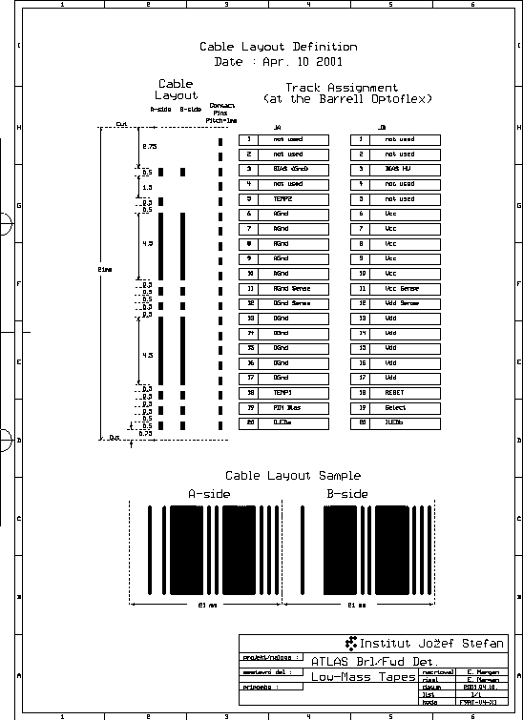

Fig.1: Layout of the barrel LM tape

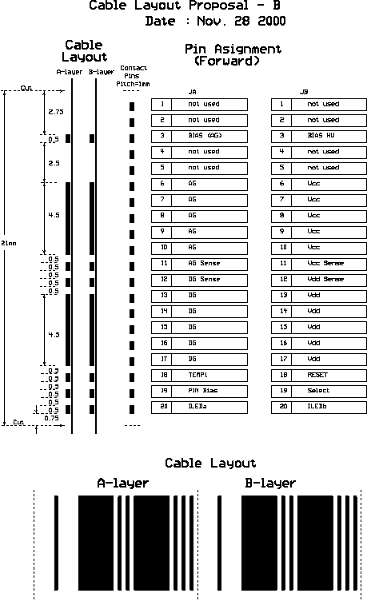

Fig 2.: Layout of the end-cap LM tape

Tape construction
Basic materials originate from GTS Ltd. (holder of ISO 9001 ). They form a matched product line of:
- Al(Cu)/Kapton FPC laminate with PU glue
- glue
- glue/Kapton coverlayer

The PU glue was tested by CERN-TIS for radiation hardness at the level required, Kapton is specified as radiation hard.

The layers in the tape construction are, from bottom to top:
- 50 um Kapton/18 um PU glue/50 um Al laminate (GTS prod. # 660220AL)
- 25 um glue (GTS prod. # 102100)
- 50 um Kapton/18 um PU glue/50 um Al laminate (GTS prod. # 660220AL)
- 25 um glue/12.5 um Kapton coverlayer (GTS prod. # 322190)
All the materials are delivered in 30.5 cm wide rolls.

Tape ends are chemicaly nickel plated for contact/soldering according to IPC-6013 Class 3. Nickel minimal layer thickness is 3 um. The nickel is protected from oxygenation by 10 um thick Sn/Pb layer

Tape Specifications

Resistivity
of 4.5 mm power lines
- 250 mOhm/m round trip (± 15 %)
of 0.5 mm lines
- 2.24 Ohm/m round trip (± 20 %)
all values with nominal values for aluminium resistivity,
- Al : 2.8 uOhm.cm

GTS quotes for aluminium foil sheet resistance specification 2.5 - 2.7 uOhm.cm. Variation of resistance of ± 10 % is expected from variations in foil thickness.

Galvanisation
The tin-protected nickel plating extends to at least 2 cm from the nominal length inwards on both ends of the cable. Any over-length must be plated.

Line insulation
Conductivity between adjacent lines
- less then 1 (MOhm/m)⁻¹

Leakage current of HV line to adjacent line
- less then 100 nA/m at 500 V

line adhesion
The adhesive force at 1 mm/s pulling speed must exceed 0.4 N/mm, giving 0.2 N for 0.5 mm wide tracks.

Material
input:
- X₀(Al) = 8.9 cm
- X₀(Kapton) = 35 cm; all glues assumed ~kapton

The width of all conductors is
4*4.5 + 13(12)*0.5 = 24.5(24) mm (in brackets forward cables without the TEMP2 line)

X-section of plastic
- 21 mm * (50(K) + 18(G) + 25(G) + 50(K) + 18(G) + 25(G) + 12.5(K)) um = 4.1 x 10⁻² cm⁻²
Radiation length seen at perpendicular impact for one cable (w - width over which the material is spread)
X₁ / X₀ = (S/X₀ (Al}) + S/X₀ ({plastic})) / w = (1.23(1.20) mm² / 89 mm + 4.1 mm² / 350 mm) / w = (0.014 + 0.012) mm / w
= 0.026 mm / w

Radiation lengths at various locations for perpendicular impact:
- spread over cable (w = 21 mm) X = 0.124 % X₀
- spread over module (w = 60 mm) X = 0.043 % X₀
- end of stave over module (6 cables) X = 0.26 % X₀
- outer barrel radius (1056 cables, r = 520 mm) X = 1056 * X₁ / (2.π * r) = 0.85 % X₀ (this should be the maximum)
- at cryostat wall (1056 cables, r = 1150 mm) X = 1056 * X₁ / (2. π * r) = 0.38 % X₀
- at end of forward cylinder (988 cables, r = 590 mm) X = 988 * X₁ / (2. π * r) = 0.70 % X₀ (maximum in forward)

Beware of fast conclusions from these numbers ! In the worst case, tapes are traversed twice and at an angle of 35º (barrel) or 13º (forward). The worst-case material estimate in low-mass tapes seen by particles is therefore 3.0 % X₀ in the barrel and 3.8 % X₀ in the forward.

Space and routing
Width of the tapes
- 21 + 0.2 – 0.3 mm
Length of the tapes
- tapes are cut to nominal length + 1 cm (± 3 mm). Exact trimming of length is done upon harness production. Depending on spares economy, the over-length may be increased for some types to reduce the number of different lengths produced.

Cross-sections, using nominal thickness

- 2.1 * 0.0298.5 = 0.063 cm²

Envelopes, harness shielding & packing factors (1.2) are not taken into account.

Minimal bending radius is specified as 10 x tape thickness (according to IPC-2223 5.2.4.2.)
- r_{min} = 3. mm (thin)

The tapes (no IPC for Al !) were tested by bending over a mandrel of decreasing r = 5, 2, 0.75 mm. 100 180º bends were perfomed with a repetition rate of 1 Hz
result:
- r = 5 mm O.K.
- r = 2 mm O.K.
- r = 0.75 mm
- 30 bends O.K.
- 50 bends 1 broken line
- 100 bends 3 broken lines

The test confirmed that aluminium tape bending is safe, if IPC recommendations for copper are obeyed.

Transmission line properties
ε (Kapton) = 3.5
ε (glue) = ε (Kapton)
capacitance: C / l = ε * ε₀ * w / d
- 1.9 nF/m
inductance: L / l = u₀ d / w
- 20. nH/m
For comparison, for flat (TP) ribbon cables: C/l is typically 50 pF/m, L/l 700 nH/m .

Aging test of Low mass tape – PCB joints
Inner part of tapes will be inside N₂ atmosphere, while tapes and joints outside thermal enclosure will be exposed to CO₂ gas with not precisely known humidity². Accelerated aging tests of low mass tapes (batch FA) soldered to PCB were performed in order to evaluate possible effects of corrosion and electrochemical migration in CO₂ environment. Since the mechanism of aging and its activation energy is not known, such test just excludes processes with E_{a} above certain level.
Aging conditions:
Temperature 100ºC
Gas: CO₂ bubbled through water at 25ºC (water pressure 30 mb)
Bias: 500 V at HV line during aging
Duration of aging: 72 hours (1st step) + 48 hours (2nd step)
Acceleration factor (20º → 100º) : 110 (E_{a} = 0.5 eV) , 8000 (E_{a} = 1.0 eV)
Interline resistance, HV leakage current and line + solder joint resistance were measured before and after aging.No electrical changes have been measured (see Fig.3 and 4). Few samples were inspected under microscope (magnification 50 x), no visual damage has been observed after aging.
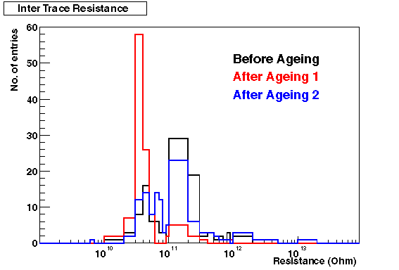

Figure 3: Resistance between the traces
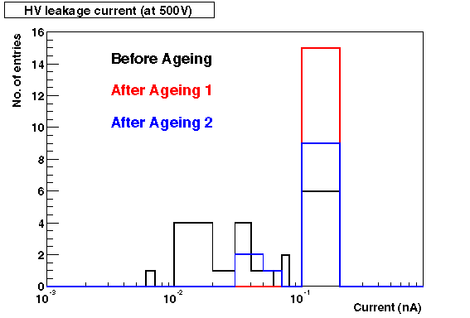
Figure. 4: HV leakage current at 500V

Production
Production is with a standard photolithographic process adapted to the size of the circuits. The steps in the production are
- Mask production
- Laminate polishing
- Photo-resist lamination
- Photo-resist exposure
- Photo-resist development
- Conductor etching
- Photo-resist stripping
- Polishing
- Ni/Su plating
- Laminate/glue/laminate/coverlay pressing
- Tape cutting

Quality control and testing
Production steps are carried out according to production sheets of the producer (available in Slovenian). In addition to the producer's own quality control, additional quality control actions are performed to ensure acceptance of the product.

Automated optical inspection
Automated optical inspection is performed after photo-resist stripping on the etched laminate sheet now containing one layer of 12 tapes. The sheet is passed at uniform speed under a camera system of 6 individual cameras covering the entire width of the sheet. The resolution of each pixel is approximately 50 microns. Repetitive images of the sheet are fed into a PC where there are processed by a neural network based optical inspection programme which follows and analyzes on-line each of the individual tracks on the tapes. The test is meant to search for and identify imperfections as breaks of lines or shorts between lines. It will be also used to control the quality of the lithography by measuring the mean, spread and minimum/maximum width of each line and the separation between them. Also any additional estimators of line quality can be programmed.

Resistance and line insulation test
Resistance and insulation of individual lines is measured after finalizing tape production by cutting individual tapes. After cutting each tape is labelled with a bar-code sticker, which is then read by the tester. The test runs on a custom test set-up including a Keithley 2000 multimeter, connected via GPIB to a PC, and a switching matrix. Each layer of the tape is connected in a test jig. The test checks line resistance for every line in a layer, its conductance to the adjacent lines and performs a leakage current test at 500 V on the HV line if present in the layer. The results are fed into a local database which is used to regularly update the ATLAS SCT database. Local database tools allow for some basic statistical operations, as calculation of yield (tapes adhering to specification), display of distributions in the quantities measured, their means and spread.

pull test
The mask for tape production comprises at the side test structures for pull tests. These will be tested regularly on a pull-tester to monitor adhesion.

Solderability test
The nickel/SnPb plating is checked by producing special short, fully plated tapes with each production series. The samples are then checked at an independent, certified laboratory for plating thickness, solderability and solderability after appropriate aging. This test is to ensure stability of the galvanic process and to guarantee solderabiity also after longer time period spent on transport or storage.

Status of Prototyping
More than a hundred prototype cables have been successfully produced on 50 um and 100 um aluminium laminates as well more than 50 on 70 um copper. They were delivered to the ATLAS SCT system test at CERN as well as to RAL for prototype harness production. Several end platings: nickel, nickel/gold, nickel/solder and nickel/tin have been applied. The resistance/insulation test has been run routinely and results are present in the database. The optical inspection tester has been delivered. Full operation of the tester has been achieved.

Harness definition and interfaces, EDMS ATL-IS-AT-0008. ² Inner Detector Thermal Management and Environmental Gas, EDMS ATL-IC-EN-0009

