PPB1 For Fibres and Low Mass Tapes
]
Abstract
This document describes the patch panel PPB1 for the SCT fibres and low mass tapes.
Prepared by : | Checked by : | Approved by :
V. Cindro, A. Nichols and T. Weidberg
Distribution List
Table of Contents
1 Scope of the document 3
2 Introduction 3
Figure1:View of PPB1, tapes and cables 3
3. PPB1-N 3
3.4 Pads for low mass tape soldering AND PIN 6
DEFINITION On MOLEX CONNECTOR 6
4 References 7

Scope of the document
This document describes the SCT patch panel for PPB1 for the ribbon fibre and low mass tapes.

Introduction
The first patch panel connection (PPB1) is situated on the LAr cryostat wall (1150mm radius) and occupies a Z space from 790mm to 980mm. Each patch panel assembly caters for two harnesses (twelve tapes). The aluminum LMTs of the barrel harness will be thermode soldered to PCBs (PPB1-N). The whole assembly is enclosed by an aluminium cover which gives mechanical protection as well as acting as a continuation of the electrical screen.
The fibre ribbons are simply connected at PPB1 using MT12 connectors. There is insufficient space for a bulkhead mounted connector housing, so the connectors are retained by a non-magnetic spring clip[Error: Reference source not found]. The bunch of connections occupies approximately the same Z region as the power tape connections and is held to the cryostat wall by a simple cover/retaining plate. This also fully encloses the area to comply with laser safety guidelines.

There is still some uncertainty about the use of thin cables or LMTs from PP2 to PPB, however any change will not affect the harness up to the PPB1-N PCB.

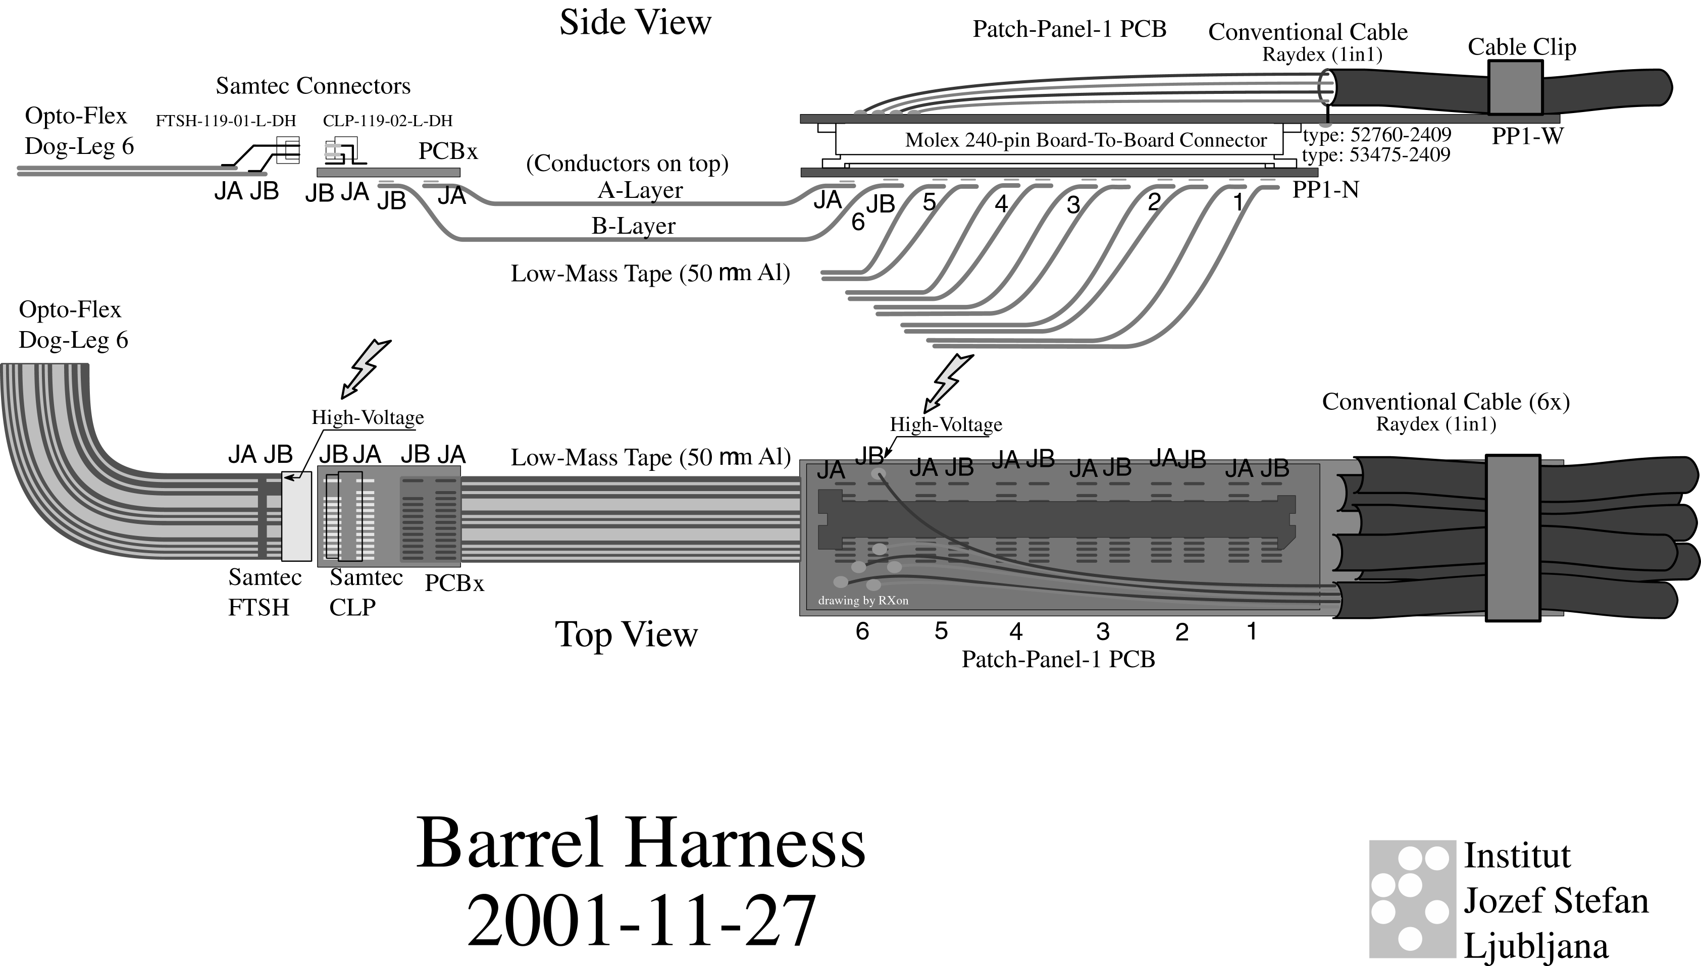

Figure1:View of PPB1, tapes and cables

3. PPB1-N
3.1 DESCRIPTION
PP1B-N is a part of PPB1, which accommodates the aluminum low mass tapes on the module side. It is connected to the PP1B-W with 240 way Molex board to board connector (53475-2409 0.635mm pitch male header is mounted on PP1B-N, 52760-2409 female receptacle is mounted on PP1B-W). The stacking height of the connector is 5 mm (more info about the connector can be found on www.molex.com). The design of PP1B-N PCB has following features:

- it provides soldering pads for thermode soldering of the low mass tapes to the printed circuit. Pad pattern was designed after thermode soldering tests done at Rutherford.
- it accepts six double layer aluminum low mass tapes, which means that it serves six modules in one harness
- together with PP1B-W it provides filtering of the noise on the electrical lines
- it provides a contact pad to connect the shield foil of the harness. There is a connection of PP1B-N shield to the PP2-shield through Molex 240 pin connector
- it is designed in three layers, with one layer serving as the shield plane
- mounting screws are connected to the shield plane
- copper conductor thickness is 35 microns
- the design obeys 2.5 mm distance (required by IPC-2221 Generic Standard on Printed Board Design) between the HV and other lines on the PCB surface
- several pins will be removed from the Molex connector to conform with the HV rule

3.2 PHYSICAL DIMENSIONS

width 38 – 0.3 mm
length 90 – 0.5 mm
thickness 2.2 – 0.2 mm
connector stacking height 5 mm

3.3 ELECTRICAL LAYOUT OF PP1B-N-V5

The electrical design of the board is based on the studies made in the system test and is called PP1-N-V5.3. The schematic is shown in Figure 2. Together with PP1B-W it provides filtering of HF noise, possibility to connect the shield of the low mass tapes to the shields of type II cables (Raydex AWG 20). PP1-N-V5.3 is an evolution of PP1-N-V3 used in the system test with the following changes:
- repositioning of Molex connector from the middle to the side to accept the new version of PP1-W for conventional cables
- providing shield connection from PP1B-N to PP1B-W through Molex connector
- repositioning of HV capacitors from PP1B-W to PP1B-N due to space limitations on PP1B-W-V5 accepting conventional cables
- extra layer for reduction of line impedances (connected to the shield)
- using three pins for power lines on Molex connector (each pin has 0.5 A current carrying capacity) to mach the 1.3 A current
- increasing the distance between the pins for HV on Molex connector to more than 2.5 mm to conform to the IPC-2221 standard

Filtering of noise is provided with capacitors. Main features are:
- 4.7μF capacitors from V_{cc}, V_{dd} to their return lines (Murata GRM31CR61A475KA01K – size 1206, 10V)
- 15 nF from HV to its return line (Murata GRM31CR72J153KW03L – size 1206, 630V)
- 0.1μF from sense, their returns, reset lines to the shield layer (Murata GRM21BR71E104KA01K – size 0805, 25V)
- 1 μF from Temp1, Temp2, Vcsela, Vcselb, Select, Pin bias, HVgnd and Agnd
to the shield plane (Murata Murata GRM21BR71C105KA01K – size 0805, 16V)
- zero ohm resistor or optional 1μF between Dgnd and shield

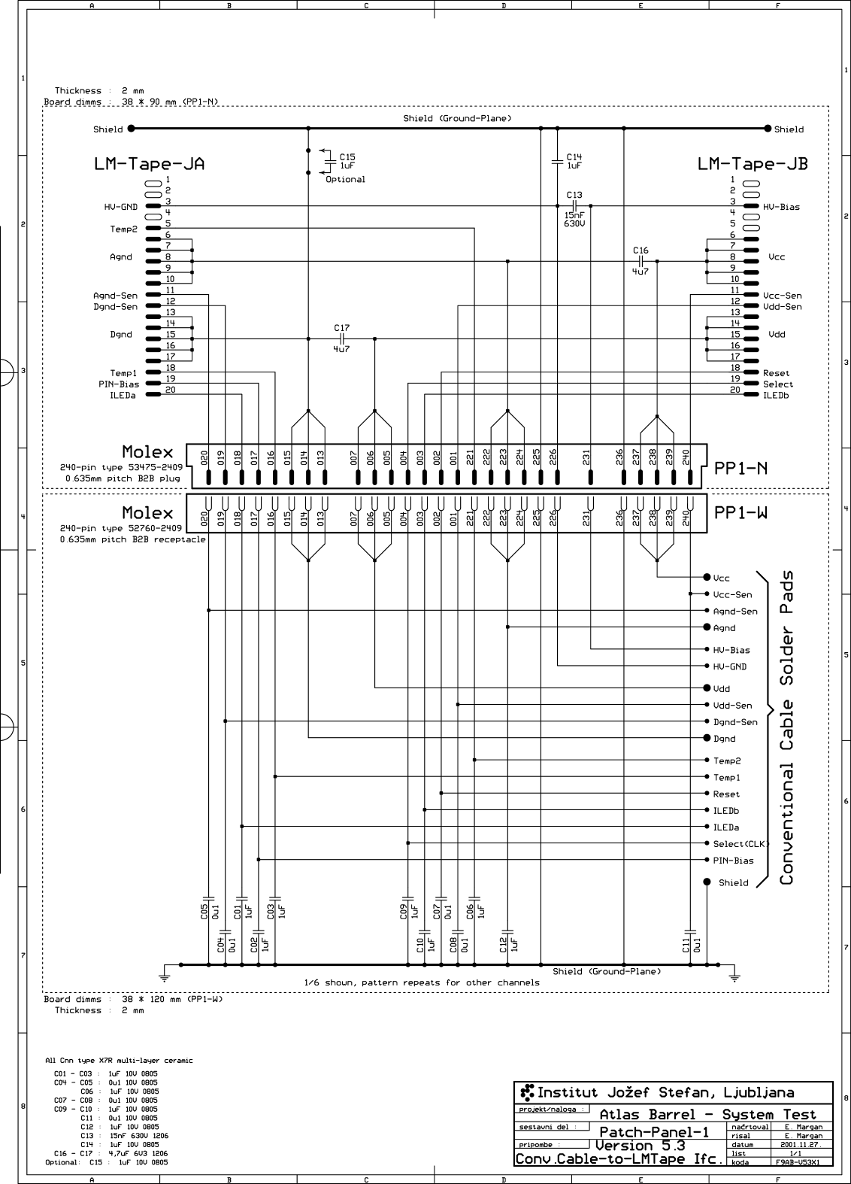
Figure2: Schematic for PP1B-N and PP1B-W

3.4 Pads for low mass tape soldering AND PIN

DEFINITION On MOLEX CONNECTOR

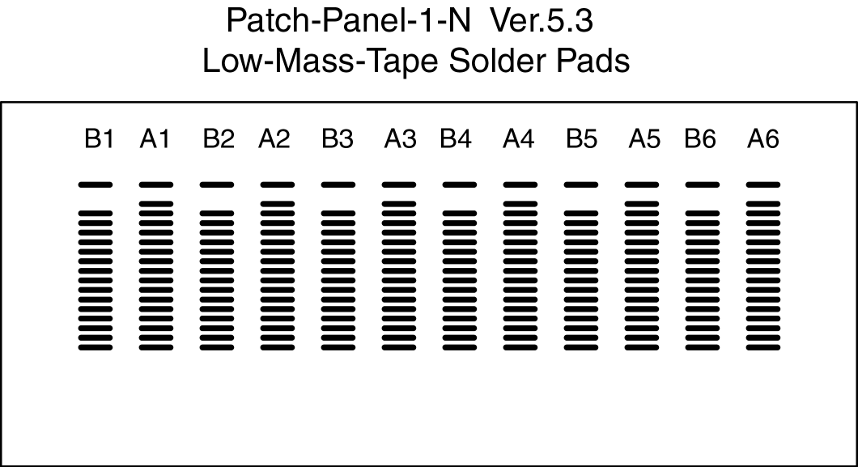
The pads for the layout of the thermode soldering of the LMTs to PP1-N are shown Figure 3 in below.

Figure 3 Layout of pads on PP1B-N-V5.3.

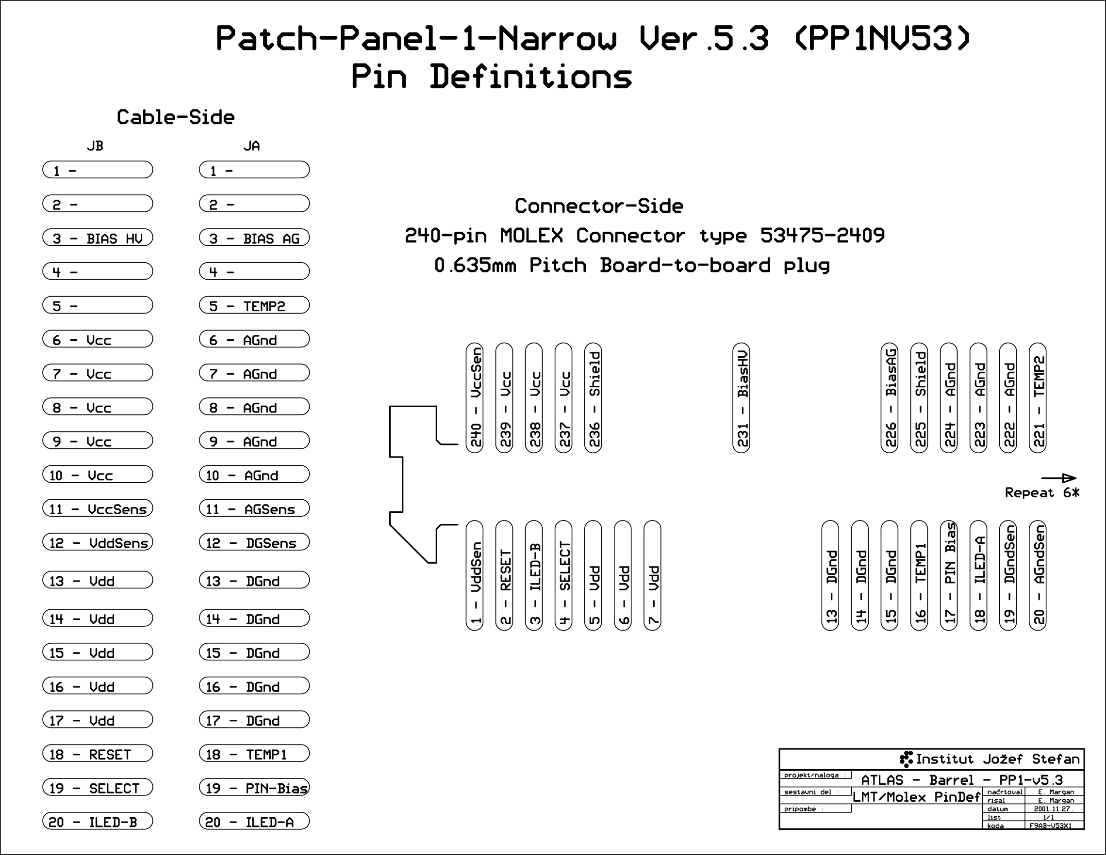

Figure 4: Pin definition on Molex connector

References

Low Mass Tapes, EDMS ATLS-IS-AT-0010 ² MT Connectors, Spring Clips and Infineon Connectors, EDMS ATL-IS-ES-0053.

