PPF1, LMT and PP0 assemblies for the forward part of the SCT
]
Abstract
This document describes assemblies of electrical PPF1, PPF0 and low mass tapes in the forward part of SCT. It defines their electrical specifications and their physical dimensions.
Prepared by : | Checked by : | Approved by :
V. Cindro, M. Mikuž | Jason Tarrant, Anthony Weidberg
Distribution List

1 Scope of the docuMent 2
2 Description of the components 2
2.1 PPF1 2
2.2 PPF0 3
2.3 Technical SPECIFICATIONS FOR PCB: 7
3. Tape lengths 8

Scope of the docuMent
Low mass tapes (LMTs) soldered to the electrical printed circuit boards PPF1s and PPF0s represent assemblies mounted on the outer wall of the forward SCT cylinder. The routing of the LMTs is described in details in EDMS document Explanation of LMT harness routing from PPF0 to PPF1 ATL-IS-EN-0026. Parts needed for such assemblies and their technical specifications are described in this document. This document also defines the physical dimensions of the assemblies

Description of the components
Components of assemblies are:
- Low mass tapes with two equal conductor layers (see EDMS document ATLAS-IS-CS-0014)
- Printed circuit boards PPF0 and PPF0T described in this document
- Printed circuit boards PPF12 and PPF13 described in this document

PPF1
There are two types of PPF1 boards: three way PPF13 boards with three positions for tapes and two way PPF12 boards with two positions. Since each forward is divided into quadrants, each with same tape layout, also there are two forwards and the smallest number of equal assemblies mounted in the SCT is 8. 496 PF12 boards and 360 PPF13 boards are needed for the forward SCT, with 25 percent spare parts this number increases to 620 PPF12 boards and 450 PPF13 boards.
PPF1 boards have similar electrical function as PPB1 boards described in PPB1 For Fibres and Low Mass Tapes ATL-IS-ES-0057. The main differences are:
- it has four layers of conductors instead of eight
- DGND is AC connected to the shield plane of the board (DC on the barrel)
- Line called TEMP2 on the Type II cable (FCI pin 20) propagates to pad 20 (called ILEDb on the barrel) in B layer of low mass tape and to the wiggly tape where it ends on solder pad . This line is meant as a spare line.
- Topology of connector and tape placement is different

Filtering of noise is provided with capacitors. Main features are:

- 4.7μF capacitors from V_{cc}, V_{dd} to their return lines (Murata GRM31CR61A475KA01K – size 1206, 10V)
- 15 nF from HV to its return line (Murata GRM31CR72J153KW03L – size 1206, 630V)
- 0.1μF from sense, their returns, reset lines to the shield layer (Murata GRM21BR71E104KA01K – size 0805, 25V)
- 1 μF from Temp1, Temp2 (ILEDb), Vcsela, Select, Pin bias, HVgnd and Agnd
to the shield plane (Murata GRM21BR71C105KA01K – size 0805, 16V)
- 1μF between Dgnd and shield

Electrical schematic of PPF1 is shown in Fig. 1.

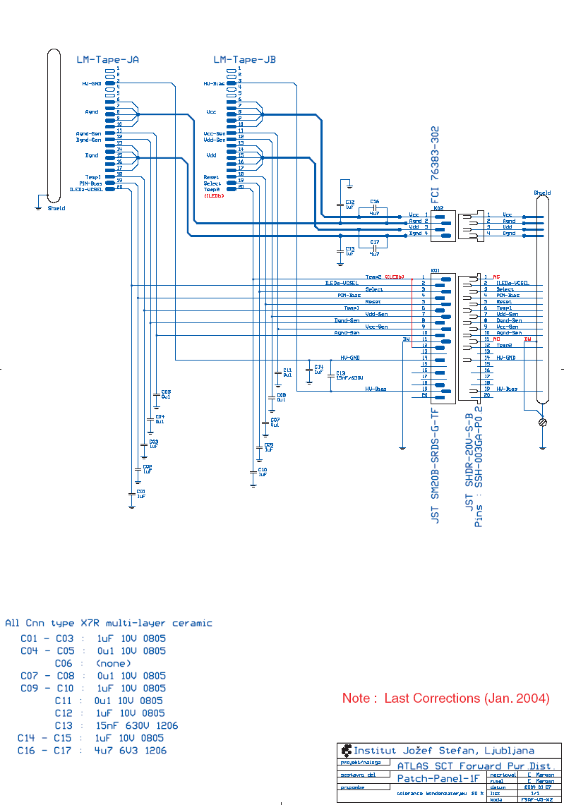

Fig. 1.: Electrical schematic of PPF1

PPF0
PPF0 boards are mating to wiggly tapes at the edge of the disk. Up to 3 positions of the wiggly tapes are equipped with 30-pin Samtec CLP-115-02-L-D connectors and each accepts one PPF0 board with the mating Samtec FTSH-115-02-L-DH connector. The board routes traces from the connector to LMT solder pads and provides RC filtering for the VCSEL (ILEDa) line. Its electrical schematic is shown in Fig. 2.

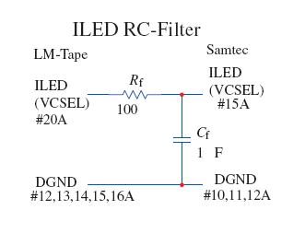
Fig. 2: Electrical schematic of PPF0 and PPF0T

Because Disk 9 is turned by 180 degrees with respect to the other 8 disks, and the on-disk services are equal for all disks, the 180 degree rotation (mirroring) of the traces is accomplished at PPF0. Therefore special PPF0T are used for Disk 9 (see also Fig. 3).
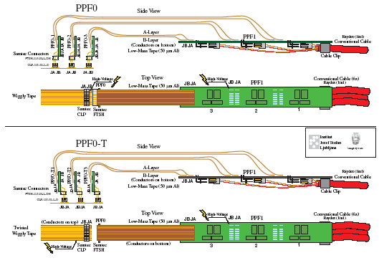
Fig. 3

Definition of pins and layout of conductors in PPF0 are shown in Fig. 4, same is shown for PPF0T in Fig. 5.
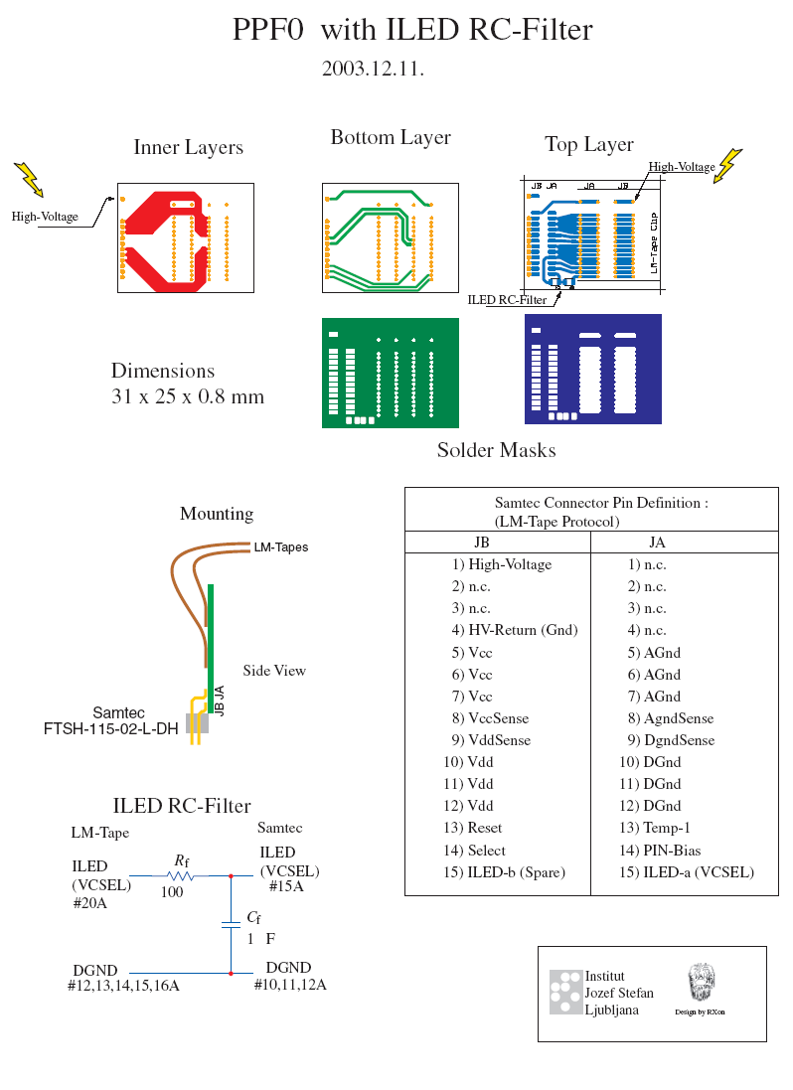
Fig. 4: PPF0 Layout

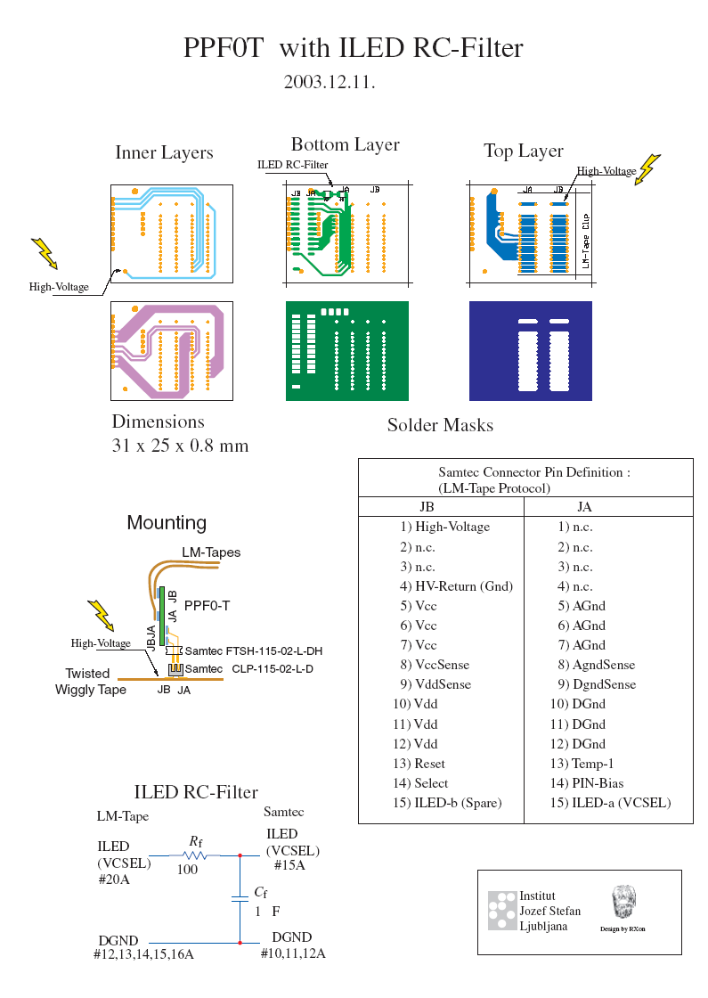

Fig. 5: PPF0T layout

Mapping of 33 modules to 12 PPF0 slots on a fully populated disks results in 9 fully populated (3 PPF0) slots and 3 populated with 2 PPF0's. On disks missing the inner ring (Disks 1, 7. 8) and on Disk 9 (outer only) only up to two PPF0 are present. The complete module to PPF1 mapping and numbering can be found in SCT End-cap LM tape mapping table – module to PPF1 (ATL-IS-EN-0024) and End-cap Module and Services Position Numbering Scheme (ATL-IS-EN-0021)

Technical SPECIFICATIONS FOR PCB:
Boards should be fabricated in the accordance with IEC 60326-4, -5 and -6 standard with the following additional specifications:
Conductor: copper 35 ± 3 µm thick
Solder resist: 30 - 40 µm thick

Surface on the pads intended for the soldering of low mass tapes should be uniformly covered with SnPb solder allowing reliable soldering of tapes. It is produced with appropriate openings of screen printing masks and heat reflow of the paste. The thickness of the solder is 30 - 50 µm.

After the assembly with components, the boards should be tested by the producer. Following tests shall be performed:

1. Connectivity and Capacitance test
a.)Connection from the connector to the capacitance required
b.)Resistance up to 2 MΩ Between any two lines or ground - rejected
c.)Capacitance value agrees within 20 percent with nominal
2. Trace resistance test: measurement of the resistance between the connector and LMT solder pad with 20 Ω range and 10mΩ resolution. Resistance of each line should agree within 30 percent with the average value (average measured for that line within the production batch).
3. High voltage test: 500 V test for 10 s on the HV bias line. Leakage current between HV bias line and HV return line and between HV bias line and Ground shall be less than 100 nA.

Results of electrical tests shall be delivered to the customer.

Material used in the boards should be radiation hard up to 20 kGray.

2.4 PHYSICAL DIMENSIONS OF BOARDS

PPF13
Width 21 mm
Length 155.5 mm
PCB thickness 2 mm

PPF12
Width 21 mm
Length 112 mm
PCB Thickness 2 mm

PPF0 and PPF0T
Width 25 mm
Length 31
Thickness 0.8 mm

Tape lengths

Tapes will be soldered to PP0 on the module side and to PPF1 on the power supply side. In order to fit into the limited space tape lengths were calculated on the basis of engineering drawings. The routing of the LMTs and their lengths are defined in details in Explanation of LMT harness routing from PPFo to PPF1 (EDMS document ATL-IS-EN-0026) and Spreadsheet of Low Mass Tape Length from PPF0 to PPF1 on SCT end-cap (ATLAS-IS-ES-0095). On the basis of this document a simplified table containing tape lengths and PPF0 – PPF1 edge to edge distances (definition in Fig. 6) was created. It is available on http://www-f9.ijs.si/~cindro/cables/forward/Taiwan-production.xls. Measured distances between the boards should agree with the nominal values given in the table better than within ± 4mm.

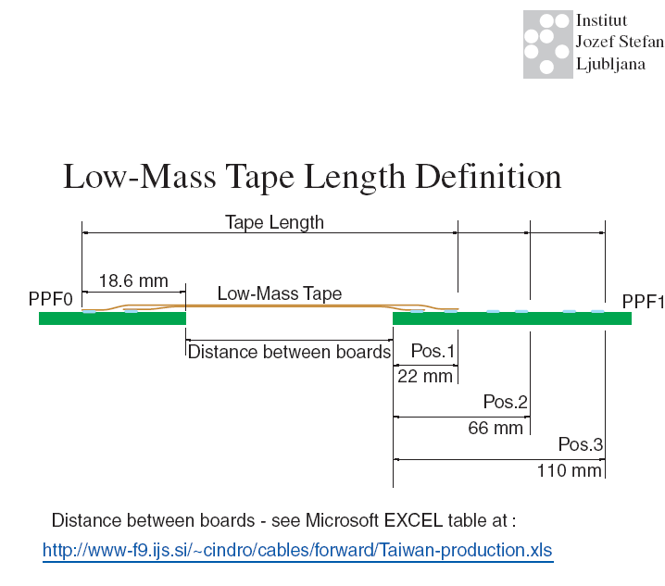

RElated documents

Explanation of LMT harness routing from PPF0 to PPF1 ATL-IS-EN-0026
PPB1 For Fibres and Low Mass Tapes ATL-IS-ES-0057.
SCT End-cap LM tape mapping table - module to PPF1 ATL-IS-EN-0024
End-cap Module and Services Position Numbering Scheme ATL-IS-EN-0021
Spreadsheet of Low Mass Tape Length from PPF0 to PPF1 on SCT end-cap ATLAS-IS-ES-0095

