Technical Specification
for the ATLAS SCT Low-Mass Tapes
ATLAS Project Document No : |  |  | Page: 1 of 12
ATL-IS-ES-00xx |  |  | Rev. No .: 1.0

Technical specification for the manufacture and supply of low-mass tapes for the ATLAS SCT detector

Abstract

This Technical Specification concerns the manufacture and supply of low-mass power tapes on aluminium-Kapton™ laminates to supply power and control to ATLAS SCT modules. 5110 tapes are to be supplied.
The delivery of the first batch of tapes is planned for December 2002.

Table of Contents
1 INTRODUCTION 3
2 SCOPE Of The supply 3
3 Material supplied to the contractor 3
4 Description of Product 4
5 QUALITY cONTROL 4
5.1 Automated optical inspection 4
5.2 Electrical test 4
5.3 Tests of conductor and tape processing 5
5.4 Electroplating tests 5
5.5 Dimensions 5
5.6 Acceptance procedure 5
6 Packaging 5
7 Delivery schedule 6
8 purchase option 6
Appendix A: Tape lengths 7
A.1: B-tape lengths and delivery schedule 7
A.2: F-tape lengths 8
Appendix B.1: Mask for layer A (not to scale) 9
Appendix B.2: Mask for layer b (not to scale) 10
Appendix B.3: Plating and lamination B-Tapes 11
Appendix B.4: Plating and lamination F-Tapes 12

INTRODUCTION
The European Organisation for Nuclear Research (CERN) is an Intergovernmental Organisation with 20 European Member States*. CERN has its seat in Canton of Geneva (Switzerland) but straddles the Swiss-French border. Its objective is to provide for collaboration among European States in the field of high-energy particle physics research and to this end it designs constructs and runs the necessary particle accelerators and the associated experimental areas.
The Large Hadron Collider (LHC) project, a large proton collider and super-conducting accelerator of 27 km of circumference was approved in 1994. The LHC machine will mainly accelerate and collide 7 TeV proton beams. It will be installed in the existing tunnel, about 100 m underground.
Four experiments are planned to use the outcome of the two colliding beams. Two largest experiments – the ATLAS and CMS experiment – are each being constructed by approximately 2000 collaborators in 150 institutes around the world. These detectors are foreseen to begin operation in the year 2007.
The low-mass tapes are being used inside the ATLAS Inner Detector to supply power, sensing and control signals to the read-out electronics and high voltage bias to the silicon strip detectors of the ATLAS SemiConductor Tracker (SCT). Due to stringent requirements on material and space, custom fabrication as large-scale flexible circuits on aluminium-Kapton™ laminates is requested.

SCOPE Of The supply
The total quantity to be produced is 5110 (nominal 4088 plus 25 % overhead to cover losses during harness production) double-layer tapes processed on Al/Kapton™ laminate sheets with the lengths specified in Appendix A. The transverse patterns A and B to be processed on the sheets are given in Appendices B.1 and B.2. There are two flavours of tapes, 2640 barrel type tapes (B-tapes) combine two sheets with pattern A and pattern B, while 2470 endcap type tapes (F-tapes) are composed of two equal sheets of pattern B, yielding 12 double-layer tapes on a laminated double-sheet. The layout of lamination is given in Appendices B.3 and B.4.

Material supplied to the contractor
- Photolithographic masks (films) supplied free of charge by the “Jožef Stefan” Institute (hereafter referred to as “JSI”). There are 12 single-layer tapes on each mask. There are two different mask sets (patterns A & B). The mask layout is given in Appendices B.1 and B.2. The number of supplied masks shall enable the Contractor to change masks after each 100 exposures.
- Tape self-adhesive labels and Kapton™ adhesive tape supplied free of charge by JSI.
- 50 μm Al /50 μm Kapton™ laminate (product # 660220AL) in quantity of 1000 m² in rolls of 305 mm width free of charge by Atlas SCT UK. The adhesion of Al to Kapton™ shall be at least 0.5 N/mm measured at 1 mm/sec peel (GTS specification).
- Adhesive film on release paper (product # 102100) and coverlayer (product # 322190) free of charge by Atlas SCT UK in quantity of 500 m² each in rolls of 305 mm width.
The quantities under c) and d) correspond to the nominal foreseen for production at the 80 % target yield plus a 25 % reserve. Upon completion of Contract, the Contractor shall return the unused Material to JSI.

Description of Product
The double-layer tapes shall be produced on the Material supplied to the Contractor in the following production sequence:
- Line pattern corresponding to the mask shall be formed on sheets of Al laminate with the photoetching process.
- Both sheet ends shall be plated with Ni (4–6 μm thick) and Sn/Pb (5–15 μm thick) on the last 5.5-6.5 cm.
- Double-layer sheets shall be manufactured by lamination of two single-layer sheets by a glue layer (GTS product # 102100) and coverlayer (GTS product # 322190). The end 5-6 cm on each end of the sheets shall not be laminated with the adhesive, so that at least 0.5 cm of the plating shall remain in the laminated region. The coverlayer shall cover the plating for 0.5-1.0 cm.
- Double-layer sheets shall be cut to 12 double-layer tapes of 21 mm width according to drawings of Appendix B.
- The double-layer tapes shall be labelled with a sticky bar-code label at 20 cm from the patch panel tape end. The labels shall be covered by Kapton™ adhesive tape.

QUALITY cONTROL

Automated optical inspection
Processed single-layer sheets shall be subjected to automated optical inspection, developed by JSI. The inspection shall be performed by the Contractor on each of the processed sheets. Acceptance criteria of the inspection are:
- Underetching of any of the processed conductor lines shall be less than 100 microns.
- Conductor width reduction shall not exceed 30 % of the nominal respective conductor width of 0.5 or 4.5 mm.
- Conductor spacing shall not be reduced by more than 0.15 mm with respect to the nominal value of 0.5 mm (2.5 mm for the HV line) due to conductor edge roughness, spikes, etc.
Raw camera images and test reports generated by the optical inspection shall be delivered to JSI for checks, documentation and further analysis.

Electrical test
Before shipment, each of the double-layer tapes shall be subjected to a resistance measurement and high voltage test by the Contractor. The method shall be agreed by the Contractor and JSI and the test equipment located at the Contractor. Acceptance criteria of the inspection are:
- Line resistance shall be smaller than 0.15 Ω/m for 4.5 mm lines and 1.7 Ω/m for 0.5 mm lines.
- Inter-line resistance shall be greater than 20 MΩ.
- Leakage current on the HV line to the grounded adjacent lines shall be less than 500 nA at 500 V DC voltage (resistance in excess of 1 GΩ) 5 s after voltage application at room temperature and relative humidity below 50 %.
Results of electrical test of each individual tape shall be delivered and submitted for approval to JSI.

Tests of conductor and tape processing
These checks shall be performed by the Contractor during processing on a regular basis:
- The production process shall not change Al thickness, checked on the aluminium of the test structures after photoetching, by more than 10 %.
- There shall be no lifted Al lands on the delivered tapes.
- Imperfections on edges (nicks and tears), in particular due to cutting, shall be less than 0.5 mm.
- Adhesive flow on coverlayer edges shall not be more than 2 mm.
- Misalignment of lines in the top and bottom layers shall be smaller than 0.2 mm in the laminated area.

Electroplating tests
These tests shall be performed by JSI and Academia Sinica on a sample of tapes and test structures:
- Electroplated surface shall be solderable in accordance with IEC 68-2-20.
- Final plating adhesion shall be tested in accordance with IPC-TM-650, method 2.4.1. using a strip of pressure sensitive tape. There shall be no evidence of any portion of the plating or the conductor pattern foil being removed.
- In addition the adhesion will be measured by pulling a soldered tape from PCB. There shall be no failure at a pull force under 10 N resulting from poor nickel adhesion to aluminium.

Dimensions
Dimensions of the double-layer tapes shall be checked by the Contractor on a regular basis according to following criteria:
- Average thickness of tapes shall not exceed 330 μm except on transition spots where tapes are laminated twice. There the thickness shall not exceed 400 μm.
- Tape width shall be less than 21.2 mm measured at any position along the tape.
- The length of tapes shall not be shorter than the value given in the list of Appendix A; the additional length shall not exceed 10 mm.

Acceptance procedure
JSI reserves the right to randomly check either at the Contractor’s premises or at JSI the conformity of tapes to the acceptance criteria specified in Sections 5.1, 5.2, 5.3, 5.4 and 5.5 before their shipment to Academia Sinica
Provisional acceptance based on the above criteria shall be signed off by Academia Sinica, Taiwan, in two weeks upon arrival of each delivery batch to Taiwan. All test results will be submitted to CERN for approval.
Final acceptance shall be signed off by CERN after expiry of the guarantee period i.e. twenty-four months after delivery of the last batch.

Packaging
For shipping the Supply shall be packaged so that the Supply may not be damaged during transportation. Tapes shall be transported rolled to reels with inner diameter greater than 5 cm.
Tape length(s), number of products in the package, production lot number or year/month of manufacturing shall be marked on package.

Delivery schedule
The delivery of B and F-tapes shall be in 6 batches each, the first two batches of approximately 10 %, the remaining of 20 % of the respective total quantity. The first batch shall be shipped within 6 weeks after placement of the Contract. The details on batches are given in Appendix A. For F-tapes the first batch will not be shipped sooner than two weeks after the shipment of the last B-tape batch. The interval between batches is 2 working weeks for 10 % batches and 4 working weeks for 20 % batches. Two weeks spanning Christmas and New Year do not count as working weeks, as well as two weeks in July or August.

purchase option
Additional quantities of tapes may be ordered until end of June 2004 at the same unit price and contractual conditions as under the original Contract. The order for each tape length, when not exceeding 24 tapes, must come in multiples of 8 tapes. The minimum total number of tapes per order is 40.

Appendix A: Tape lengths

A.1: B-tape lengths and delivery schedule

B-tapes to order
Pos. no. | Length | No. of tapes | Total length
1 | 860 | 140 | 120400
2 | 908 | 60 | 54480
3 | 979 | 90 | 88110
4 | 1014 | 100 | 101400
5 | 1085 | 40 | 43400
6 | 1145 | 150 | 171750
7 | 1193 | 60 | 71580
8 | 1236 | 70 | 86520
9 | 1276 | 120 | 153120
10 | 1307 | 140 | 182980
11 | 1345 | 100 | 134500
12 | 1393 | 150 | 208950
13 | 1441 | 150 | 216150
14 | 1488 | 140 | 208320
15 | 1546 | 160 | 247360
16 | 1582 | 140 | 221480
17 | 1627 | 100 | 162700
18 | 1661 | 90 | 149490
19 | 1698 | 80 | 135840
20 | 1769 | 110 | 194590
21 | 1840 | 110 | 202400
22 | 1909 | 80 | 152720
23 | 1945 | 100 | 194500
24 | 2016 | 80 | 161280
25 | 2085 | 80 | 166800
Total |  | 2640 | 3830820

Delivery batches  B-tapes | Batch 1 | Batch 2 | Batch 3 | Batch 4 | Batch 5 | Batch 6
After Contract placement | 6 weeks | + 2 weeks | + 4 weeks | + 4 weeks | + 4 weeks | + 4 weeks
Tentative shipping date | 02-Dec-02 | 16-Dec-02 | 27-Jan-03 | 24-Feb-03 | 24-Mar-03 | 21-Apr-03
Pos. no. | tapes | tapes | tapes | tapes | tapes | tapes
1 |  |  | 140
2 |  |  |  | 30 | 30
3 |  |  | 70 |  |  | 20
4 |  |  |  | 100
5 |  |  |  |  | 30 | 10
6 |  |  | 140 |  |  | 10
7 |  |  |  | 30 | 30
8 |  |  |  |  | 60 | 10
9 |  |  | 70 |  |  | 50
10 |  |  |  | 100 |  | 40
11 | 40 |  |  |  | 60
12 |  | 40 | 70 |  | 30 | 10
13 |  |  |  | 100 |  | 50
14 | 40 |  |  |  | 60 | 40
15 |  | 40 | 70 |  | 30 | 20
16 |  |  |  | 100 |  | 40
17 |  |  |  |  | 60 | 40
18 | 40 | 40 |  |  |  | 10
19 |  |  |  |  | 30 | 50
20 | 40 |  |  |  | 30 | 40
21 |  | 40 |  |  | 30 | 40
22 | 40 |  |  |  |  | 40
23 |  | 40 |  |  | 60
24 |  |  |  |  |  | 80
25 | 40 | 40
Total in batch | 240 | 240 | 560 | 460 | 540 | 600

A.2: F-tape lengths

The length range of F-tapes is from 1800 to 3600 mm. The maximum overall length is 7250 m. The 2470 tapes to produce shall be grouped to cover 40 mm wide bins in length of at least 40 tapes each, yielding at most 40 different lengths to produce.

Appendix B.1: Mask for layer A (not to scale)

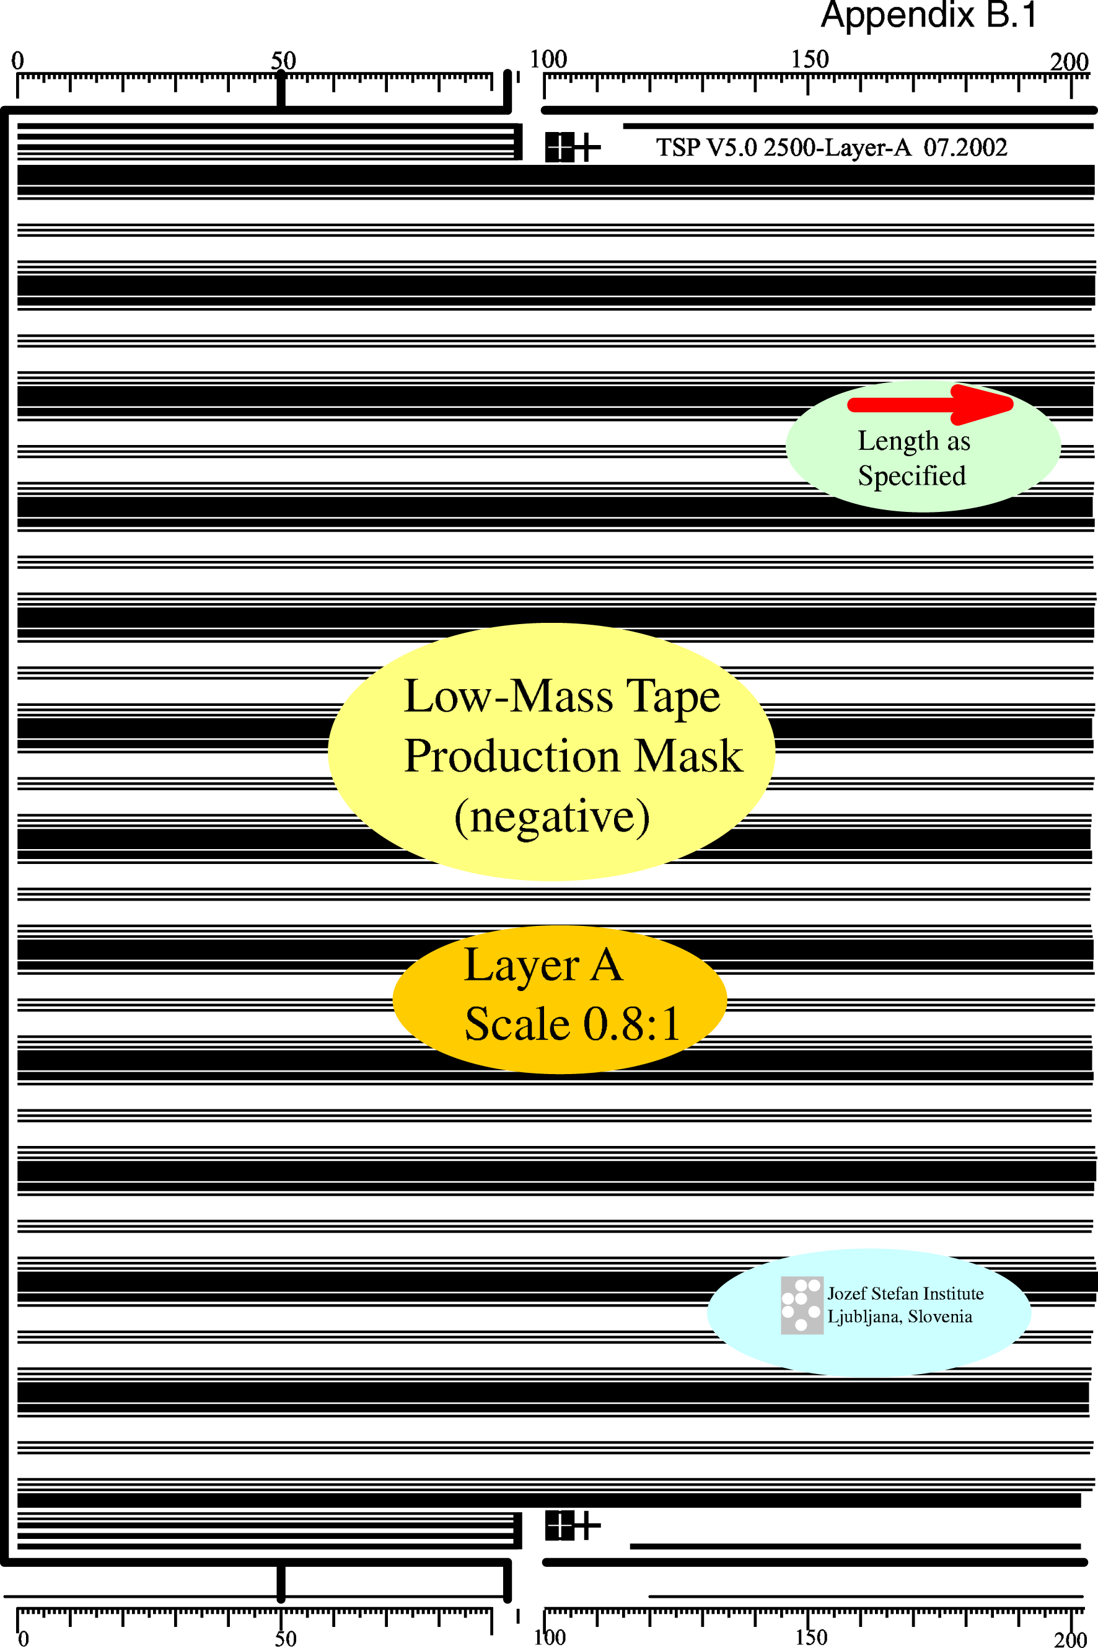

Appendix B.2: Mask for layer b (not to scale)

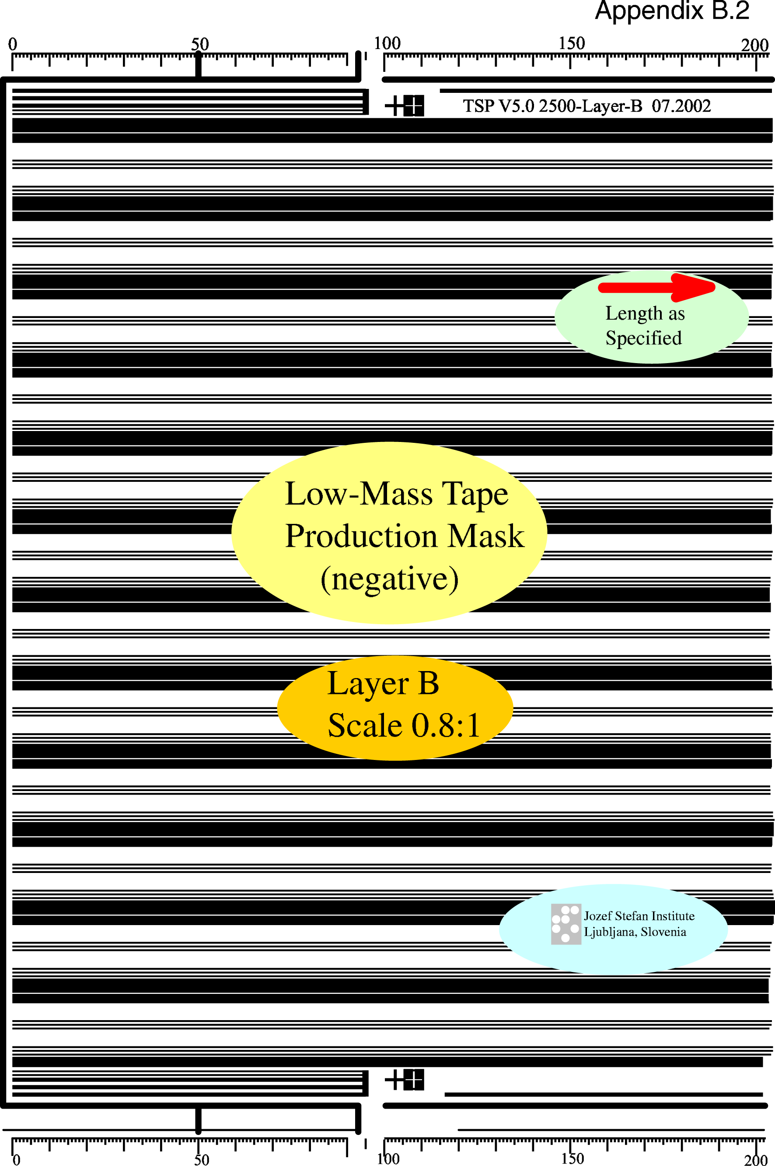

Appendix B.3: Plating and lamination B-Tapes

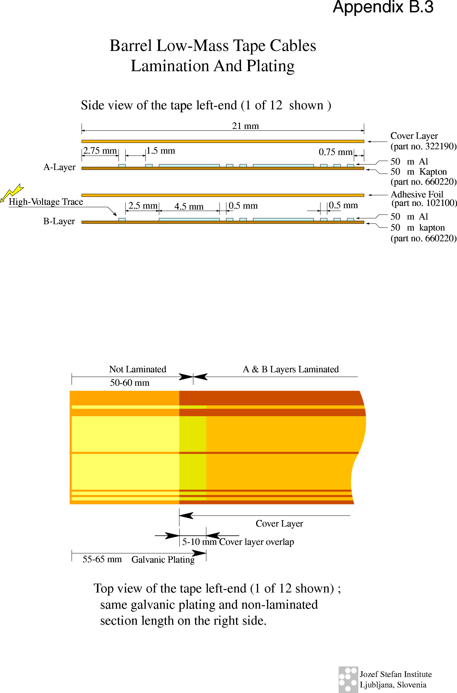

Appendix B.4: Plating and lamination F-Tapes

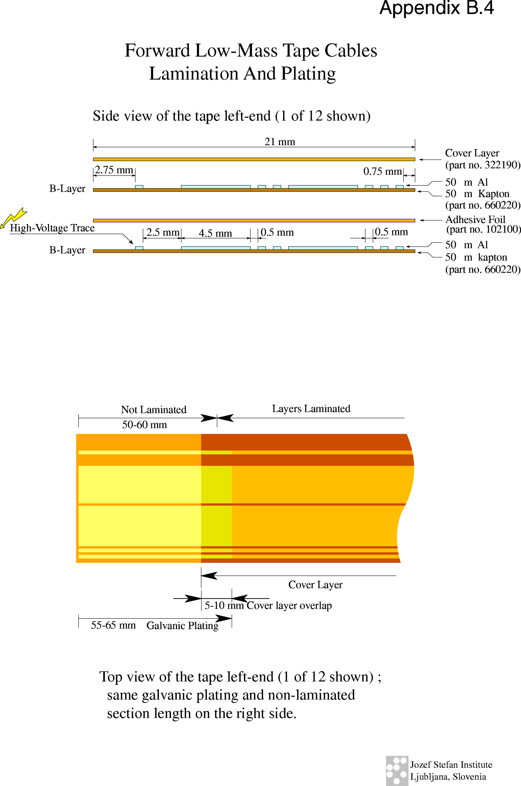

* CERN Member States are: Austria, Belgium, Bulgaria, Czech Republic, Denmark, Finland, France, Germany, Greece, Hungary, Italy, The Netherlands, Norway, Poland, Portugal, Slovak Republic, Spain, Sweden, Switzerland and the United Kingdom.

