PPB1 For Fibres and Low Mass Tapes
]
Abstract
This document describes the patch panel PPB1 for the SCT fibres and low mass tapes.
Prepared by : | Checked by : | Approved by :
V. Cindro, A. Nichols and T. Weidberg
Distribution List
Table of Contents
1 Scope of the document 3
2 Introduction 3
3.PPB1
3.1.Description.................................................................................................................................................................. 4
3.2 Physical dimensions 4
3.3 Electrical layout of PP1....................................................................................................................................... 5
3.4 Pads for low mass tape soldering AND PIN 6
DEFINITION On FCI and JST connectors 6
4 References 7

Scope of the document
This document describes the SCT patch panel PPB1 for the ribbon fibre and low mass tapes.

Introduction
The first patch panel connection (PPB1) is situated on the LAr cryostat wall (1150mm radius) and occupies a Z space from 790mm to 980mm. Each patch panel assembly caters for two harnesses (twelve tapes). The aluminum LMTs of the barrel harness will be thermode soldered to PCBs, while the conventional cables will be attached via connectors. The whole assembly is enclosed by an aluminium cover which gives mechanical protection as well as acting as a continuation of the electrical screen.
The fibre ribbons are simply connected at PPB1 using MT12 connectors. There is insufficient space for a bulkhead mounted connector housing, so the connectors are retained by a non-magnetic spring clip[Error: Reference source not found]. The bunch of connections occupies approximately the same Z region as the power tape connections and is held to the cryostat wall by a simple cover/retaining plate. This also fully encloses the area to comply with laser safety guidelines.

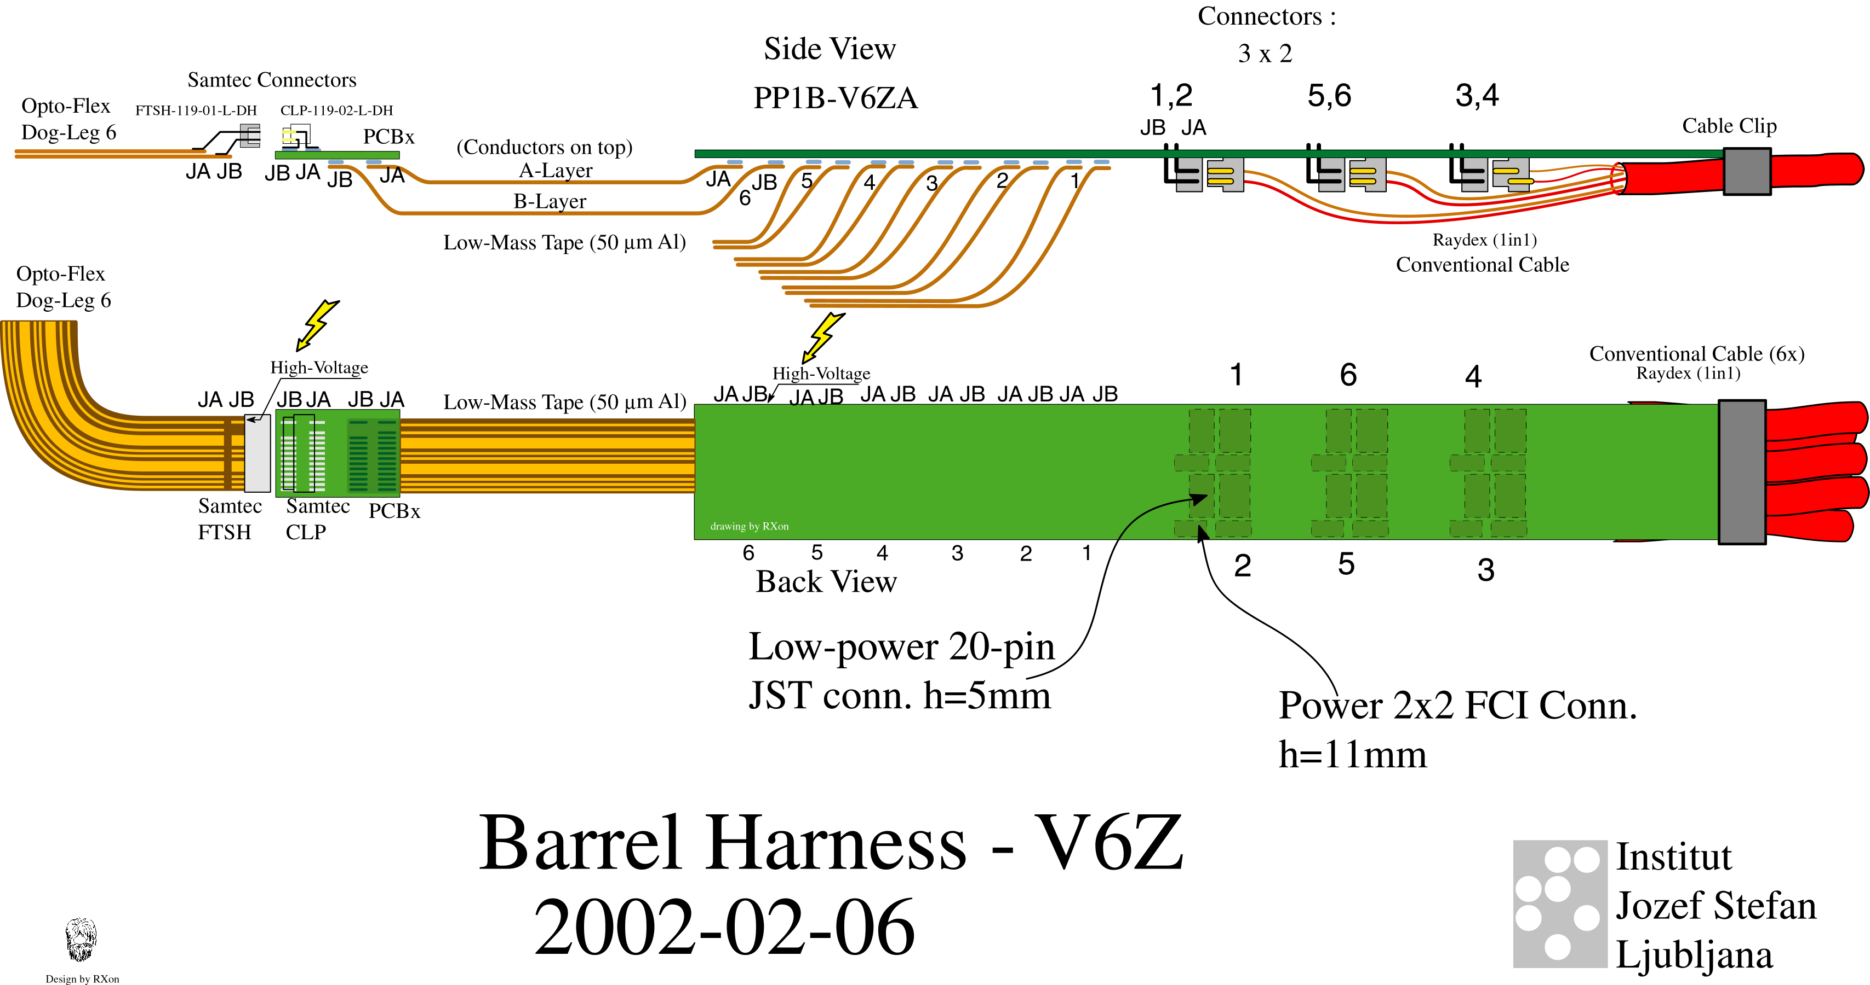

Figure1:View of PPB1, tapes and cables

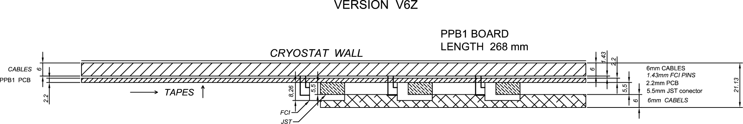
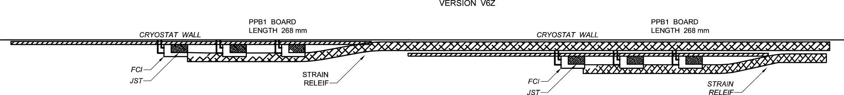

Figure 2: One and two PPB1 mounted on the cryostat wall

3. PPB1
3.1 DESCRIPTION
PPB1 accommodates the aluminum low mass tapes on the module side and conventional cables with connectors on the power supply side. One conventional cable accomodates two connectors (4 pin JST for power lines and 20 pin FCI connector for other lines). The design of PPB1 PCB has following features:

- it provides soldering pads for thermode soldering of the low mass tapes to the printed circuit. Pad pattern was designed after thermode soldering tests done at Rutherford
- it accepts six double layer aluminum low mass tapes, which means that it serves six modules in one harness
- it provides filtering of the noise on the electrical lines
- the conventional cable shield foil will be in electrical contact with a digital ground layer of the PPB1. The electrical contact is made with a conductive cable clip
- it is designed in eight layers, with three layers having a large surface with a shield
- mounting screws are connected to the shield plane
- copper conductor thickness is 35 microns
- the design obeys 2.5 mm distance (required by IPC-2221 Generic Standard on Printed Board Design) between the HV and other lines on the PCB surface
- several pins will be removed from FCI connectors to conform with the HV rule

3.2 PHYSICAL DIMENSIONS

width 38 ± 0.2 mm
length 268 ± 0.3mm
PCB thickness 2.2 ± 0.2 mm

3.3 ELECTRICAL LAYOUT OF PPB1

The electrical design of the board is based on the studies made in the system test and is called PPB1-V6Z. The schematic is shown in Figure 3. It provides filtering of HF noise. PPB1-V6Z is an evolution of PP1N-V3 and PP1W-V3 assembly used in the system test with the following changes:
- integration of two boards into one board with 8 layers
- connectors (4 pin FCI and 20 pin JST) will be used to connect type II cables (Raydex AWG 20).

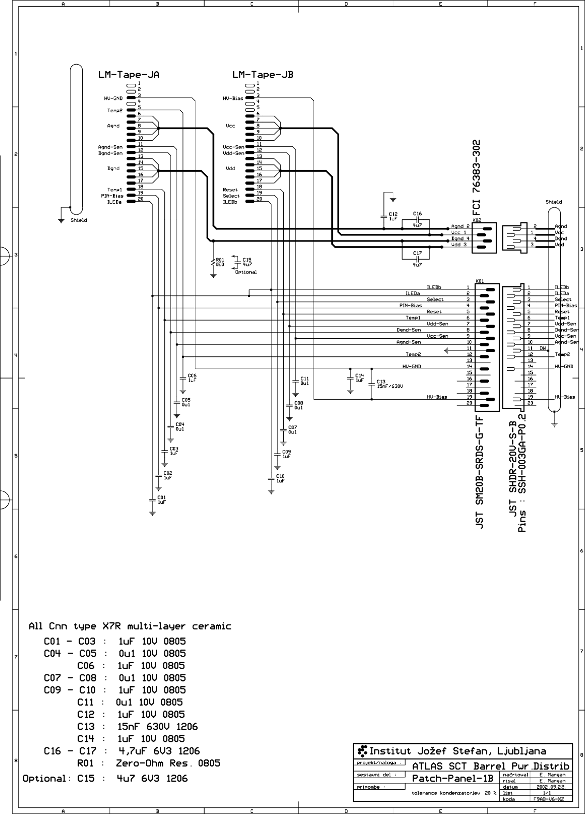
Figure 3: Schematic for PPB1

Filtering of noise is provided with capacitors. Main features are:

- 4.7μF capacitors from V_{cc}, V_{dd} to their return lines (Murata GRM31CR61A475KA01K – size 1206, 10V)
- 15 nF from HV to its return line (Murata GRM31CR72J153KW03L – size 1206, 630V)
- 0.1μF from sense, their returns, reset lines to the shield layer (Murata GRM21BR71E104KA01K – size 0805, 25V)
- 1 μF from Temp1, Temp2, Vcsela, Vcselb, Select, Pin bias, HVgnd and Agnd
to the shield plane (Murata Murata GRM21BR71C105KA01K – size 0805, 16V)
- zero ohm resistor or optional 1μF between Dgnd and shield

3.4 Pads for low mass tape soldering AND PIN

DEFINITION On FCI and JST CONNECTOR

The pads for the layout of the thermode soldering of the LMTs to PPB1 are shown Figure 4 in below.

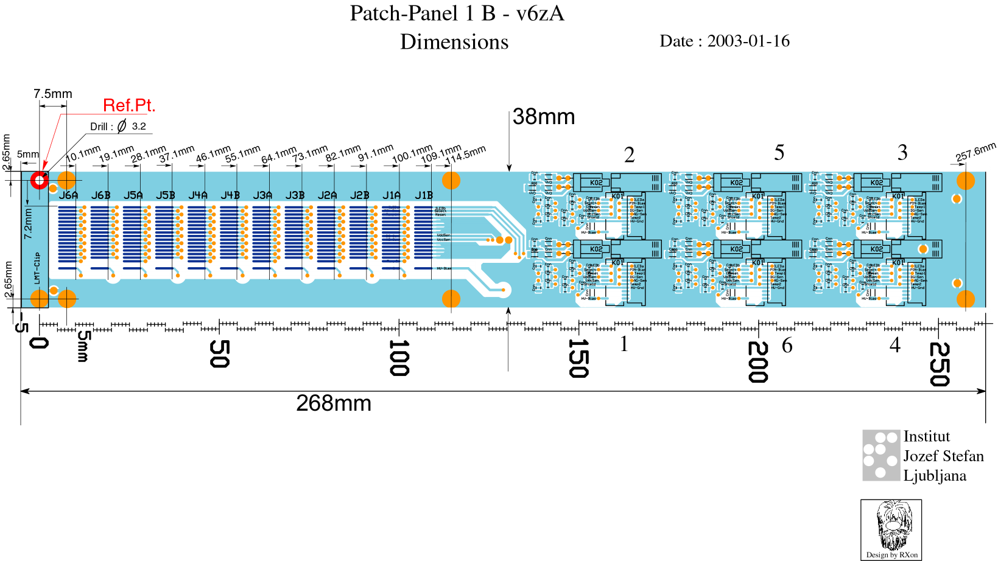

Figure 4 Layout of pads on PP1B

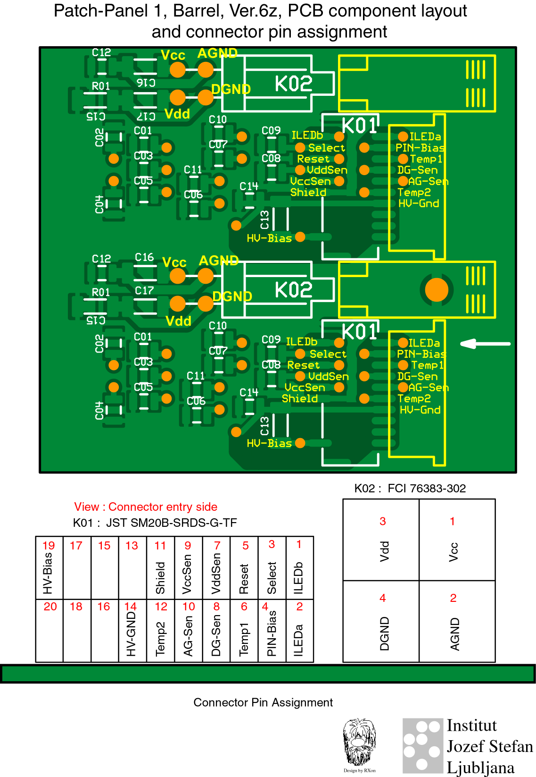

Figure 5: Pin definition on FCI and JST connectors

References

Low Mass Tapes, EDMS ATLS-IS-AT-0010 ² MT Connectors, Spring Clips and Infineon Connectors, EDMS ATL-IS-ES-0053.

