Technical Specifications
for the ATLAS SCT Low-Mass Tapes
ATLAS Project Document No : |  |  | Page: 1 of 23
ATL-HT-CS-0001 |  |  | Rev. No .: 1.0

Technical specifications for the manufacture and supply of low-mass tapes for the ATLAS SCT detector

Abstract

These Technical Specifications concern the manufacture and supply of low-mass power tapes on aluminium-Kapton™ laminates to supply power and control to ATLAS SCT modules. 5110 tapes are to be supplied.
The delivery of the first batch of tapes is planned for November 2002.

Table of Contents
1 INTRODUCTION 4
2 SCOPE Of The supply 4
2.1 Deliverables to the contractor (input deliverables) 4
2.2 Deliverables by contractor 5
3 Description of Product 5
4 Acceptance QA 5
4.1 Automated optical inspection 5
4.2 Electrical test 5
4.3 Tests of conductor and tape processing 6
4.4 Electroplating tests 6
4.5 Dimensions 6
5 Acceptance procedure 6
6 Packaging 6
7 Delivery schedule 6
8 Additional production option 7
Appendix A: Tape lengths 8
A.1: B-tape lengths 8
A.2: F-tape lengths 9
Appendix B.1: Mask for layer A (not to scale) 10
Appendix B.2: Mask for layer b (not to scale) 11
Appendix B.3: Plating and lamination B-Tapes 12
Appendix B.4: Plating and lamination F-Tapes 13

INTRODUCTION
The European Organisation for Nuclear Research (CERN) is an Intergovernmental Organisation with 20 European Member States*. CERN has its seat in Canton of Geneva (Switzerland) but straddles the Swiss-French border. Its objective is to provide for collaboration among European States in the field of high-energy particle physics research and to this end it designs constructs and runs the necessary particle accelerators and the associated experimental areas.
The Large Hadron Collider (LHC) project, a large proton collider and super-conducting accelerator of 27 km of circumference was approved in 1994. The LHC machine will mainly accelerate and collide 7 TeV proton beams. It will be installed in the existing tunnel, about 100 m underground.
Four experiments are planned to use the outcome of the two colliding beams. Two largest experiments – the ATLAS and CMS experiment – are each being constructed by approximately 2000 collaborators in 150 institutes around the world. These detectors are foreseen to begin operation in the year 2007.
ATLAS detector consists of magnets and several sub-detectors dedicated to measure certain elementary particles. Typically these components weigh from 450 metric tons to 1600 metric tons, and are up to 15 metres in diameter. During maintenance periods these massive parts of the experiment are moved with the help of the air-pads to provide proper access to the internal areas. Manufacture and supply of these air-pad units is the object of the present Invitation to Tender.

SCOPE Of The supply
The total quantity to produce is 5110 (nominal 4088 plus 25 % overhead to cover losses during harness production) double-layer tapes processed on Al/Kapton™ laminate sheets with the lengths specified in Appendix A. The transverse patterns A and B to be processed on the sheets are given in Appendix B.1 and B.2. There are two flavours of tapes, 2640 barrel type tapes (B-tapes) combine two sheets with pattern A and pattern B, while 2470 endcap type tapes (F-tapes) are composed of two equal sheets of pattern B, yielding 12 double-layer tapes on a laminated double-sheet. The layout of lamination is given in Appendix B.3 and B.4.

Deliverables to the contractor (input deliverables)
- Photolithographic masks (films) supplied free of charge by the Jozef Stefan Institute (JSI). There are 12 single-layer tapes on each mask. There are two different mask sets (patterns A & B). The mask layout is given in Appendix B.1 and B.2. The number of supplied masks shall enable the producer to change masks after each 100 exposures.
- Tape self-adhesive labels supplied free of charge by JSI.
- 50 μm Al /50 μm Kapton™ laminate (product # 660220AL) produced by GTS Ltd., UK in quantity of 1000 m² in rolls of 305 mm width free of charge by Atlas UK.
- Adhesive film on release paper (GTS product # 102100) and coverlayer (GTS product # 322190) free of charge by Atlas UK in quantity of 500 m² each in rolls of 305 mm width. The quantities under c) and d) correspond to the nominal foreseen for production at the foreseen 80 % yield plus a 25 % reserve.

Deliverables by contractor
5110 cut and tested tapes delivered C.I.F. to Academia Sinica, Taiwan in consecutive batches of 10-20 % of total amount of either B or F-tapes. B-tapes shall be produced first, followed by F-tapes. Tapes will be delivered labelled with standard ATLAS-SCT labels. QA test results shall be made available, either as test sheets, optical scan images or entries in the ATLAS SCT database.

Description of Product
Tapes will be processed on 50 μm Al /50 μm Kapton™ laminate (product # 660220AL) produced by GTS Ltd, UK. The adhesion of Al to Kapton™ on supplied material shall be at least 0.5 N/mm measured at 1 mm/sec peel (GTS specification).
Line pattern corresponding to the mask shall be formed on Al laminate with the photoetching process.
Both sheet ends shall be plated with Ni (4–6 μm thick) and Sn/Pb (5–15 μm thick) on the last 5.5-6.5 cm.
Double-layer sheets shall be manufactured by lamination of two single-layer sheets by a glue layer (GTS product # 102100) and coverlayer (GTS product # 322190). The end 5-6 cm on each end of the sheets shall not be laminated with the adhesive, so that at least 0.5 cm of the plating shall remain in the laminated region. The coverlayer shall cover the plating for 0.5-1.0 cm.
Double-layer sheets shall be cut to 12 tapes of 21 mm width according to drawings of Appendix B.
Final tapes shall be labelled with a sticky bar-code label at 20 cm from the patch panel tape end. The labels shall be covered by Kapton™ adhesive tape.

Acceptance QA

Automated optical inspection
Processed single-layer sheets shall be subjected to automated optical inspection, developed by JSI and located at the contractor. Acceptance criteria of the inspection are:
- Underetching of any of the processed conductor lines shall be less than 100 microns.
- Conductor width reduction shall not exceed 30 % of the nominal respective conductor width of 0.5 or 4.5 mm.
- Conductor spacing shall not be reduced by more than 0.15 mm with respect to the nominal value of 0.5 mm (2.5 mm for the HV line) due to conductor edge roughness, spikes, etc.
Raw camera images and test reports generated by the optical inspection shall be delivered to JSI for documentation and further analysis.

Electrical test
Each of the final double-sided tapes shall be subjected to a resistance measurement and high voltage test with a method agreed by the contractor and JSI and located at the contractor. Acceptance criteria of the inspection are:
- Line resistance shall be smaller than 0.15 Ω/m for 4.5 mm lines and 1.7 Ω/m for 0.5 mm lines.
- Inter-line resistance shall be greater than 20 MΩ.
- Leakage current on the HV line to the grounded adjacent lines shall be less than 100 nA at 500 V DC voltage 5 s after voltage application at room temperature and relative humidity below 50 %.
Results of electrical test of each individual tape shall be delivered to JSI and entered into ATLAS SCT database by JSI.

Tests of conductor and tape processing
- The production process shall not change Al thickness, checked on the aluminium of the test structures after photoetching, by more than 10 %.
- There shall be no lifted Al lands on the delivered tapes.
- Imperfections on edges (nicks and tears), in particular due to cutting, shall be less than 0.5 mm.
- Adhesive flow on coverlayer edges shall not be more than 2 mm.
- Misalignment of lines in the top and bottom layers shall be smaller than 0.2 mm in the laminated area.

Electroplating tests
- Electroplated surface shall be solderable in accordance with IEC 68-2-20.
- Final plating adhesion shall be tested in accordance with IPC-TM-650, method 2.4.1. using a strip of pressure sensitive tape. There shall be no evidence of any portion of the plating or the conductor pattern foil being removed.
- In addition the adhesion will be measured by pulling a soldered tape from PCB. There shall be no failure at a pull force under 10 N resulting from poor nickel adhesion to aluminium.

Dimensions
- Thickness of tapes shall not exceed 330 μm except on transition spots where tapes are laminated twice. There the thickness shall not exceed 350 μm.
- Tape width shall be less than 21.2 mm measured at any position along the tape.
- The length of tapes shall not be shorter than the value given in the list of Appendix A; the additional length shall not exceed 10 mm.

Acceptance procedure
Provisional acceptance based on the above criteria shall be signed off by JSI before shipment.
Academia Sinica, Taiwan, shall sign off final acceptance in two weeks upon arrival.
The yield of the production of double layer tapes shall be greater than 80 %. For small quantities, lower yield figures can be agreed by all parties and specified in Appendix A.

Packaging
For shipping the tapes shall be packaged so that the product may not be damaged during transportation. Tapes shall be transported rolled to reels with inner diameter greater than 5 cm.
Tape length(s), number of products in the package, production lot number or year/month of manufacturing shall be marked on package.

Delivery schedule
The order is to be placed for two positions: B-tapes and F-tapes. Each of the positions carries a separate Appendix A for length specification.
The delivery of B and F-tapes shall be in 6 batches each, the first two batches of approximately 10 %, the remaining of 20 % of the respective total quantity. The first batch shall be shipped within 6 weeks after placement of the order. The details on batches are given in Appendix A. For F-tapes the first batch will not be shipped sooner than two weeks after the shipment of the last B-tape batch. The interval between batches is 2 working weeks for 10 % batches and 4 working weeks for 20 % batches. Two weeks spanning Christmas and New Year do not count as working weeks, as well as two weeks in July or August, specified by the contractor.

Additional production option
The contractor shall maintain the production ability and store the remaining input deliverables for 6 months after the last shipment but not beyond June 2004. Additional quantities of tapes may be ordered in this period at the same cost as for the original order plus an overhead cost of CHF 1500- per order. The order for each tape length, when not exceeding 24 tapes, must come in multiples of 8 tapes. If input deliverables are not sufficient to fulfil the additional order, ATLAS SCT shall supply the missing deliverables to the contractor free of charge.

Appendix A: Tape lengths

A.1: B-tape lengths

Length & Quantity to Order
No. | Length | Quantity | Total length
 | 860 | 140 | 120.40
 | 908 | 60 | 54.48
 | 966 | 80 | 77.28
 | 1014 | 110 | 111.54
 | 1085 | 40 | 43.40
 | 1145 | 150 | 171.75
 | 1193 | 90 | 107.37
 | 1251 | 110 | 137.61
 | 1287 | 160 | 205.92
 | 1335 | 130 | 173.55
 | 1393 | 190 | 264.67
 | 1441 | 150 | 216.15
 | 1502 | 170 | 255.34
 | 1546 | 130 | 200.98
 | 1608 | 210 | 337.68
 | 1654 | 110 | 181.94
 | 1714 | 90 | 154.26
 | 1783 | 140 | 249.62
 | 1854 | 80 | 148.32
 | 1925 | 140 | 269.50
 | 1996 | 80 | 159.68
 | 2065 | 80 | 165.20
Total |  | 2640 | 3806.64

Delivery schedule |  | Tapes  in bin | Batch 1  Tapes | Batch 2  Tapes | Batch 3  Tapes | Batch 4  Tapes | Batch 5  Tapes | Batch 6  Tapes
No. | Length
 | 860 | 140 | 0 | 0 | 140 | 0 | 0 | 0
 | 908 | 60 | 0 | 0 | 0 | 30 | 30 | 0
 | 966 | 80 | 0 | 0 | 70 | 0 | 0 | 10
 | 1014 | 110 | 0 | 0 | 0 | 100 | 0 | 10
 | 1085 | 40 | 0 | 0 | 0 | 0 | 30 | 10
 | 1145 | 150 | 0 | 0 | 140 | 0 | 0 | 10
 | 1193 | 90 | 0 | 0 | 0 | 30 | 60 | 0
 | 1251 | 110 | 0 | 0 | 70 | 0 | 30 | 10
 | 1287 | 160 | 0 | 0 | 0 | 70 | 0 | 90
 | 1335 | 130 | 40 | 0 | 0 | 30 | 60 | 0
 | 1393 | 190 | 0 | 40 | 70 | 0 | 30 | 50
 | 1441 | 150 | 0 | 0 | 0 | 100 | 0 | 50
 | 1502 | 170 | 40 | 40 | 0 | 0 | 90 | 0
 | 1546 | 130 | 0 | 0 | 70 | 0 | 0 | 60
 | 1608 | 210 | 40 | 0 | 0 | 100 | 30 | 40
 | 1654 | 110 | 0 | 40 | 0 | 0 | 60 | 10
 | 1714 | 90 | 0 | 0 | 0 | 0 | 0 | 90
 | 1783 | 140 | 40 | 40 | 0 | 0 | 60 | 0
 | 1854 | 80 | 0 | 0 | 0 | 0 | 0 | 80
 | 1925 | 140 | 40 | 40 | 0 | 0 | 60 | 0
 | 1996 | 80 | 0 | 0 | 0 | 0 | 0 | 80
 | 2065 | 80 | 40 | 40 | 0 | 0 | 0 | 0
Total |  | 2640 | 240 | 240 | 560 | 460 | 540 | 600

A.2: F-tape lengths

The length range of F-tapes is from 1800 to 3600 mm. The maximum overall length is 7250 m. The 2470 tapes to produce shall be grouped to cover 40 mm wide bins in length of at least 40 tapes each, yielding at most 40 different lengths to produce.

Appendix B.1: Mask for layer A (not to scale)

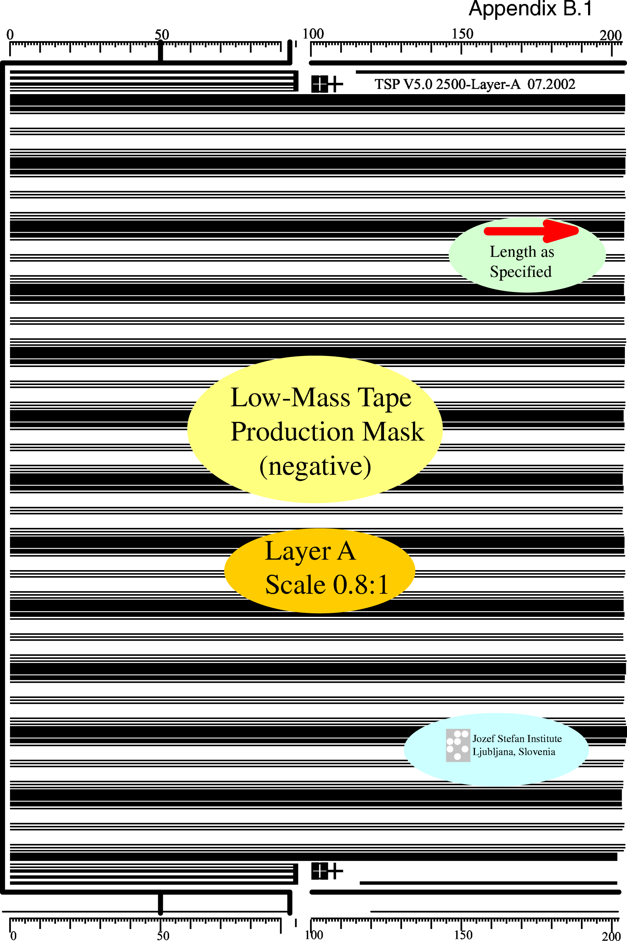

Appendix B.2: Mask for layer b (not to scale)

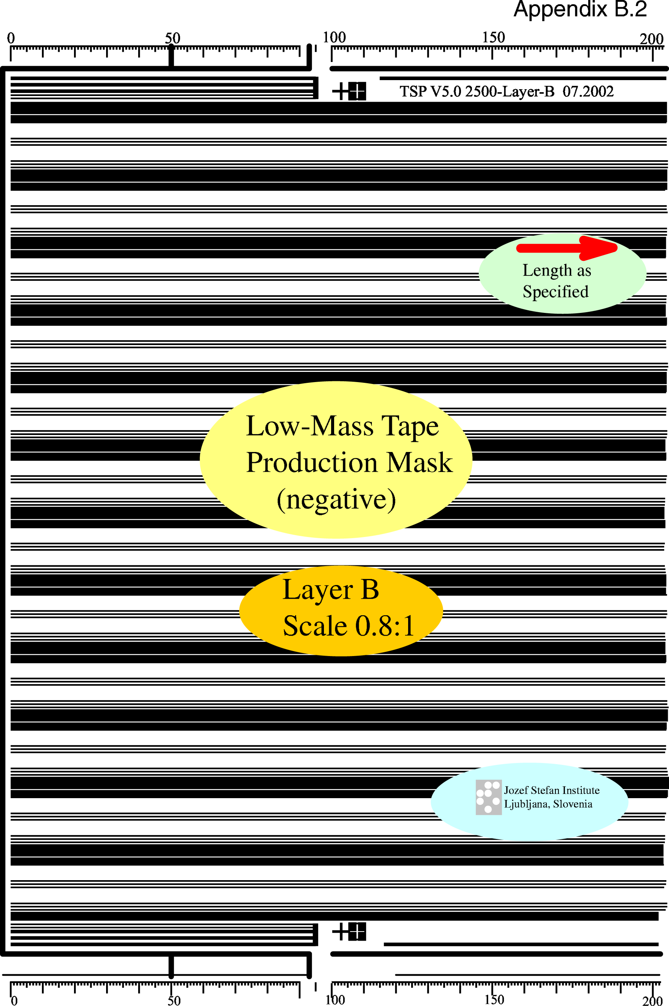

Appendix B.3: Plating and lamination B-Tapes

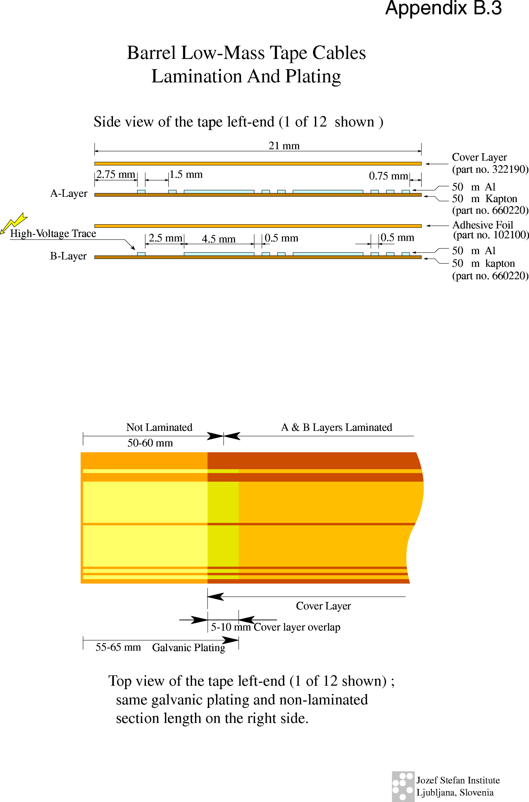

Appendix B.4: Plating and lamination F-Tapes

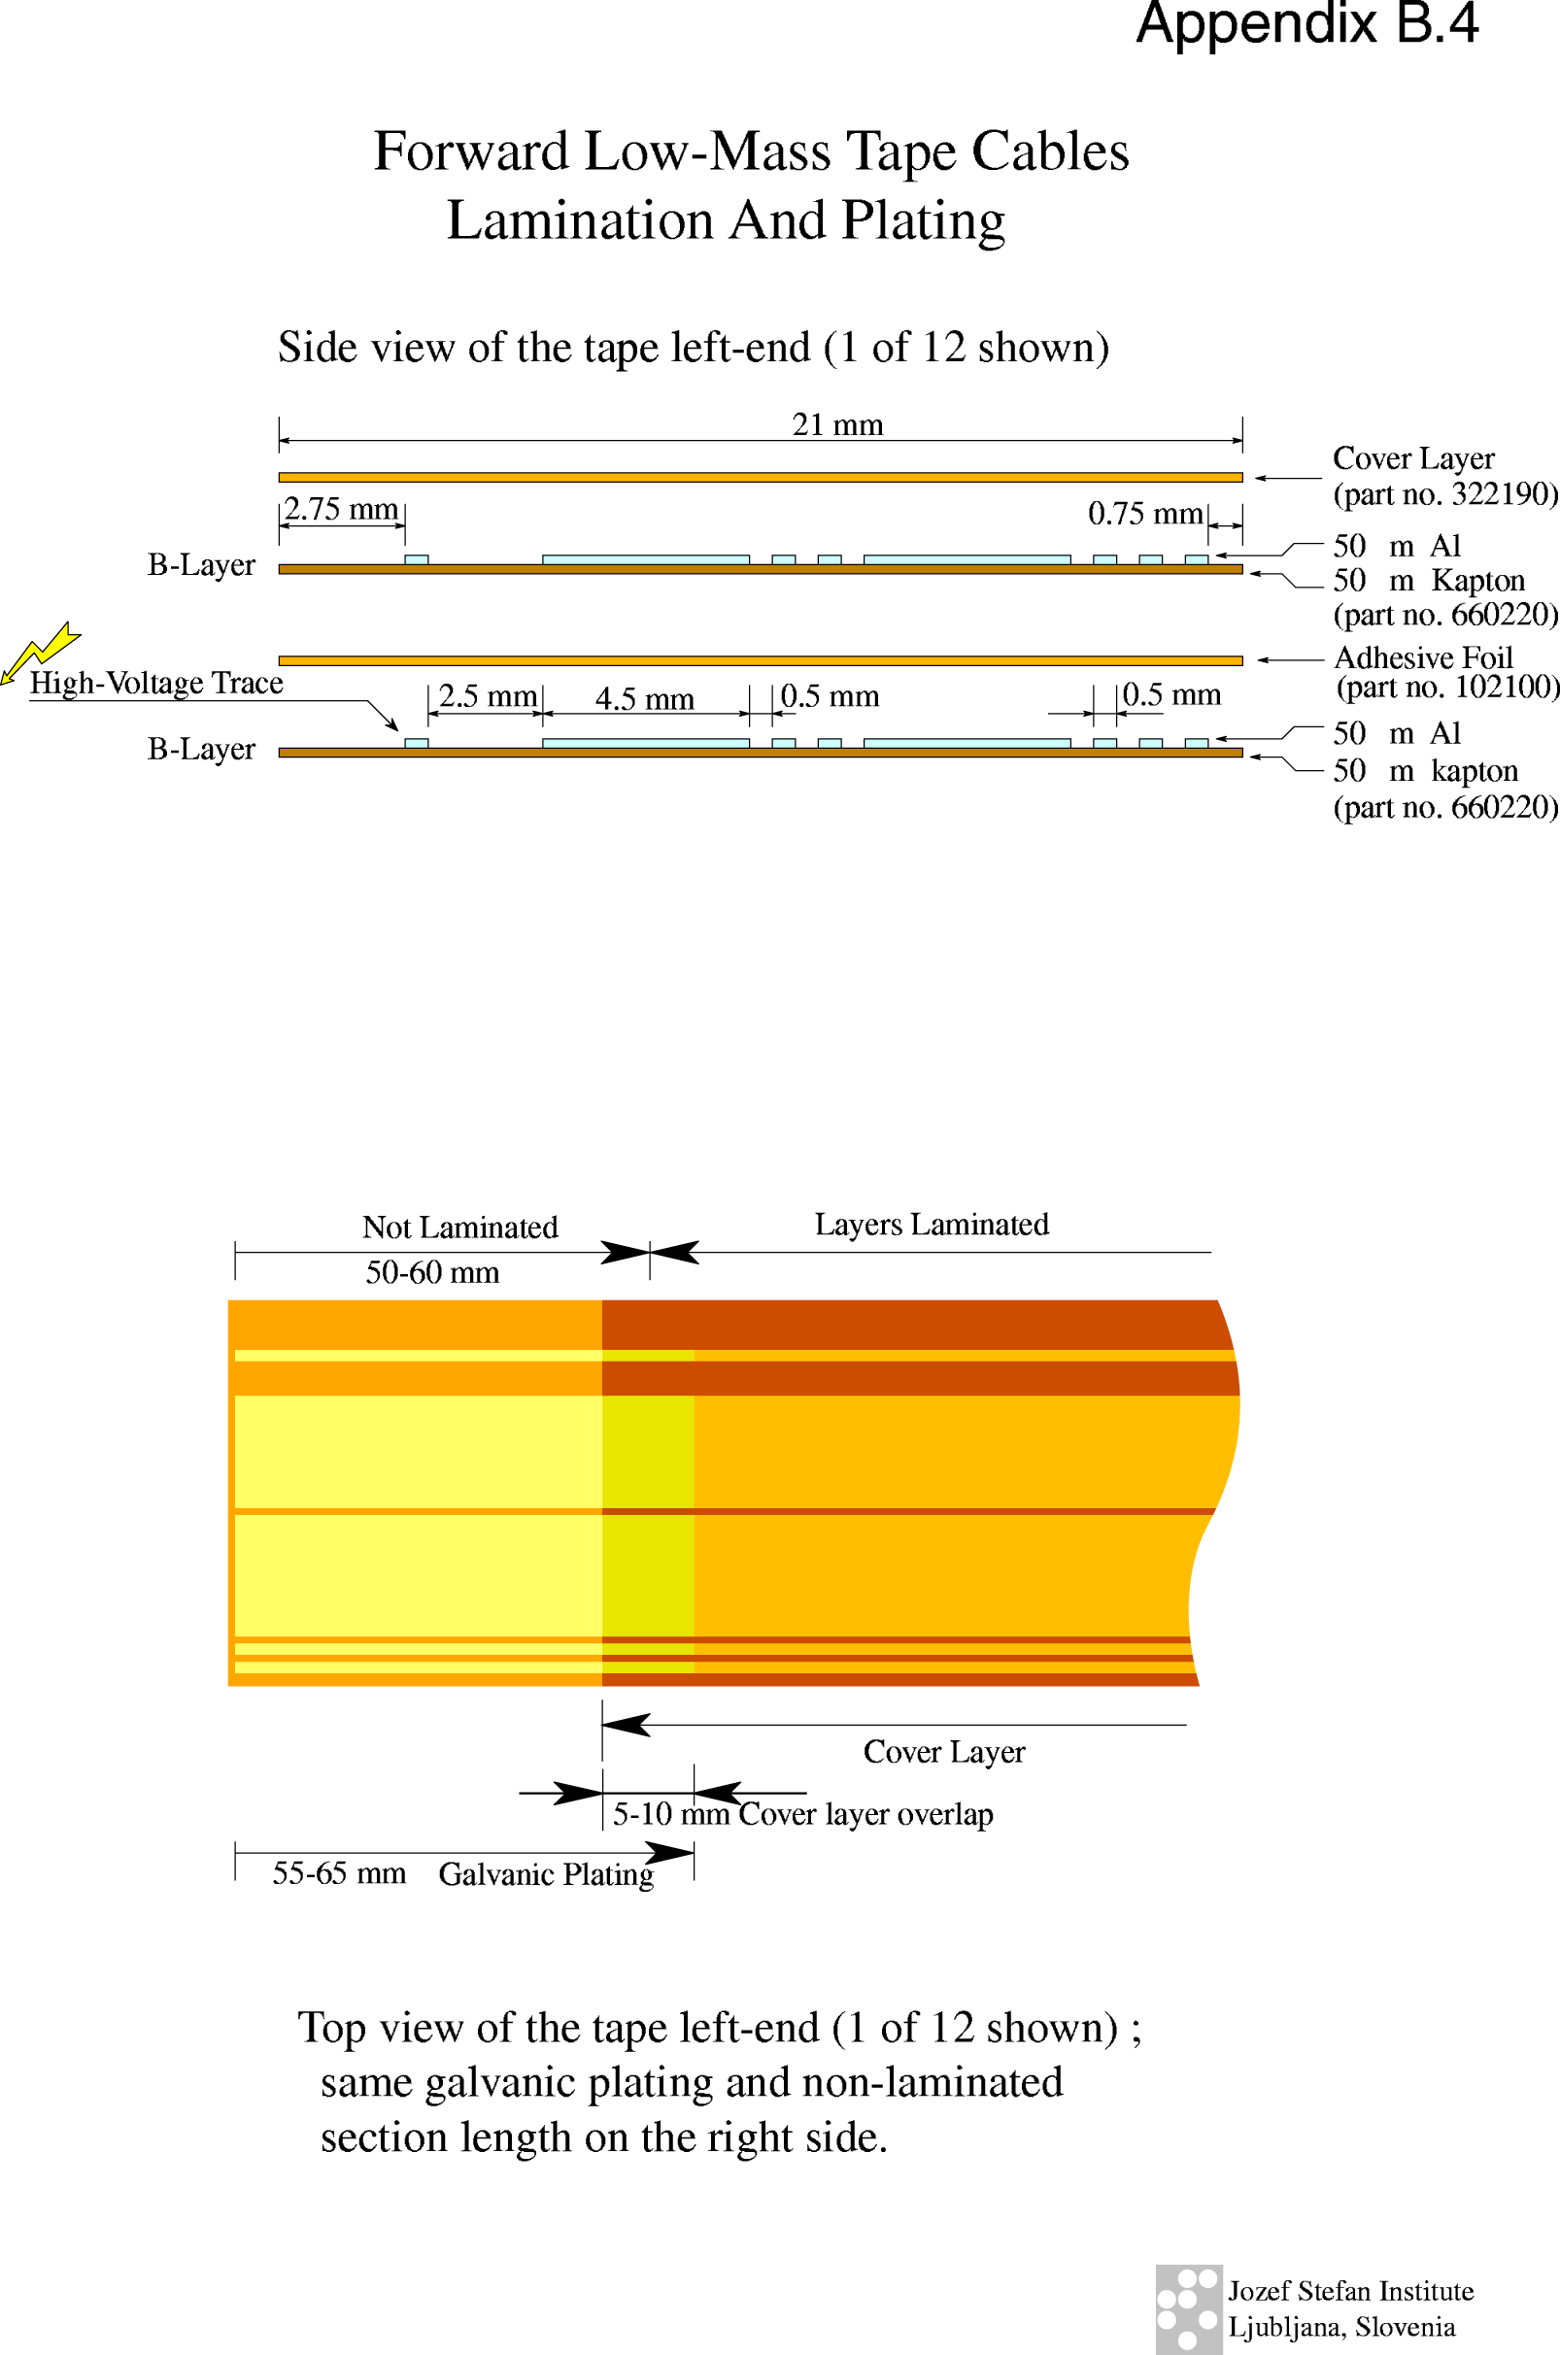

* CERN Member States are: Austria, Belgium, Bulgaria, Czech Republic, Denmark, Finland, France, Germany, Greece, Hungary, Italy, The Netherlands, Norway, Poland, Portugal, Slovak Republic, Spain, Sweden, Switzerland and the United Kingdom.

