Voltage limiter for SCT ASICs

Igor Mandić, Erik Margan, Vladimir Cindro, Marko Mikuž, Gregor Kramberger

Ljubljana ATLAS group

October 2002

CONTENTS:

- Introduction.................................................................... 2
- Radiation environment................................................... 3
- Components. .................................................................. 3
- Tests................................................................................ 3
- Results............................................................................. 4
- Conclusions..................................................................... 7
7. Appendix......................................................................... 8

1. Introduction

The function of voltage limiter circuit is to protect the readout ASICs from overvoltage. Because of large voltage drop between power supplies and ASICs caused by long cables the voltage at the power supply output will be higher then maximum voltage allowed for ASICs. The absolute maximum for ASICs is 5.5 V while the voltage at power supplies will be higher than 8 V in worst cases. In an event of sudden current drop supply voltage at modules could exceed the maximum allowed for ASICs because the reaction time of power supply control is too long (few ms). The sudden current drops could be caused by e.g. changing front end biasing DACs from normal values to 0, by loss of clock in the digital part etc.. A dedicated circuit (voltage limiter) is therefore needed to protect the ASICs against such events. The scheme of the limiter circuit is shown in Fig 1.

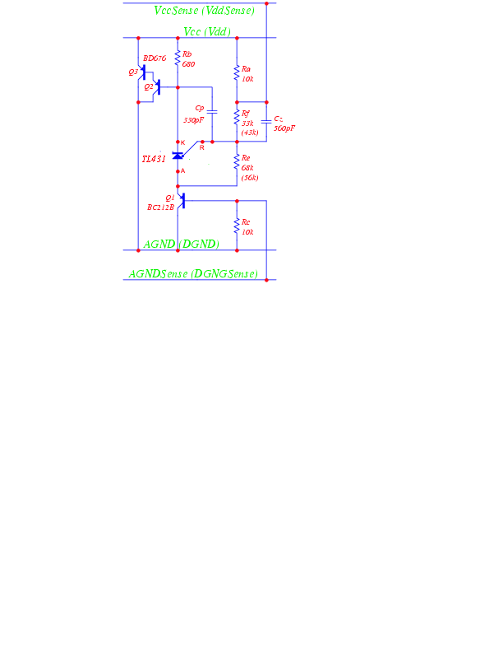

Fig 1 Voltage limiter schematic.

2. Measurements of voltage limiter time response

Measurements of voltage limiter response in time was done with barrel hybrid populated with 12 ABCD3T chips (the hybrid was irradiated with 2x10¹⁴ n/cm² in the reactor). Method of measurement: analogue voltage (Vcc) was monitored on oscilloscope at the hybrid while the currents drawn by the hybrid were switched between high and low values.
Hybrid was connected to LV3 power supply using a set of cables as close as possible to the situation in the ATLAS detector. Voltage limiter was positioned at the PP3 as will be the case in ATLAS. Setup:
- hybrid to PPB1: thin (50 μm Al) LM tape, 3 m long
- PPB1 to PP2: 9 m of very thin conventional cable
- PP2 to PP3: 25 m of thin conventional cable
- PP3 to LV3: a cable with 0.2 Ohm resistance for power lines (both ways) which corresponds to the resistance of minimal length (30 m) of thick conventional cables
- Capacitors: values of the decupling capacitors on PPB1 were 4.7 µF for power lines and 1 µF for sense lines.
- Limiter: the schematics of the limiter is shown on the figure Fig 1. The limiting voltage is set by resistors Re and Rf: Vlim = 2.5 V * (1+Rf/Re) + 0.65 V. In our case the limiting voltage for Vcc was set to 4.4 V using Rf = 33 kOhm and Re = 68 kOhm.

Current was switched between high and low values (High ~ 820mA, Low ~ 230mA) by changing the preamp current DAC settings (from all 1 to all 0 at Ishaper set to 30uA). The resistors in the limiter for analogue voltage were chosen so that it switched on if Vcc > 4.4 V at the module. On the figures Fig 2 and Fig 3 time dependence of Vcc on the module when the current is switched can be seen.

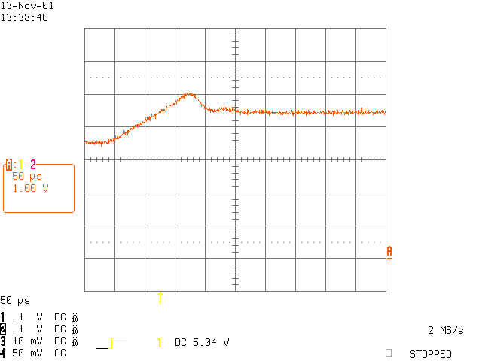

Fig 2 Vcc vs. time (short time scale).

The trace on Fig 2. shows Vcc on the module. One can see that before the current switch Vcc was 3.5V (0 is at the letter A on the right side of the picture), then we see about 0.5 V high, and 50 μs long overshoot followed by a constant Vcc = 4.4V as defined by the limiter. The same event on the longer time scale is shown in the figure Fig 3. below. Here also the action of LV3, which corrects Vcc to 3.5 V after few milliseconds, can be seen.

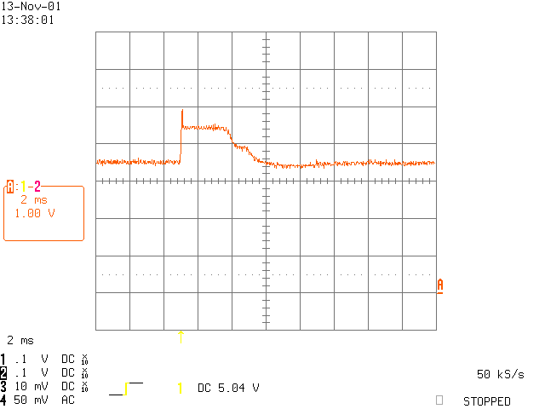

Fig 3 Vcc vs. time (long time scale).

One can compare measurement shown in figure Fig 2. with simulation done by Erik
Margan (described in his document Examination Of The Possibility Of Moving The Supply Voltage Limiter To Patch-Panel-3). The simulated voltages and currents are shown in the figure Fig 4. One can see good agreement between measured and simulated voltage at the hybrid (Det. Module Voltage in the figure).

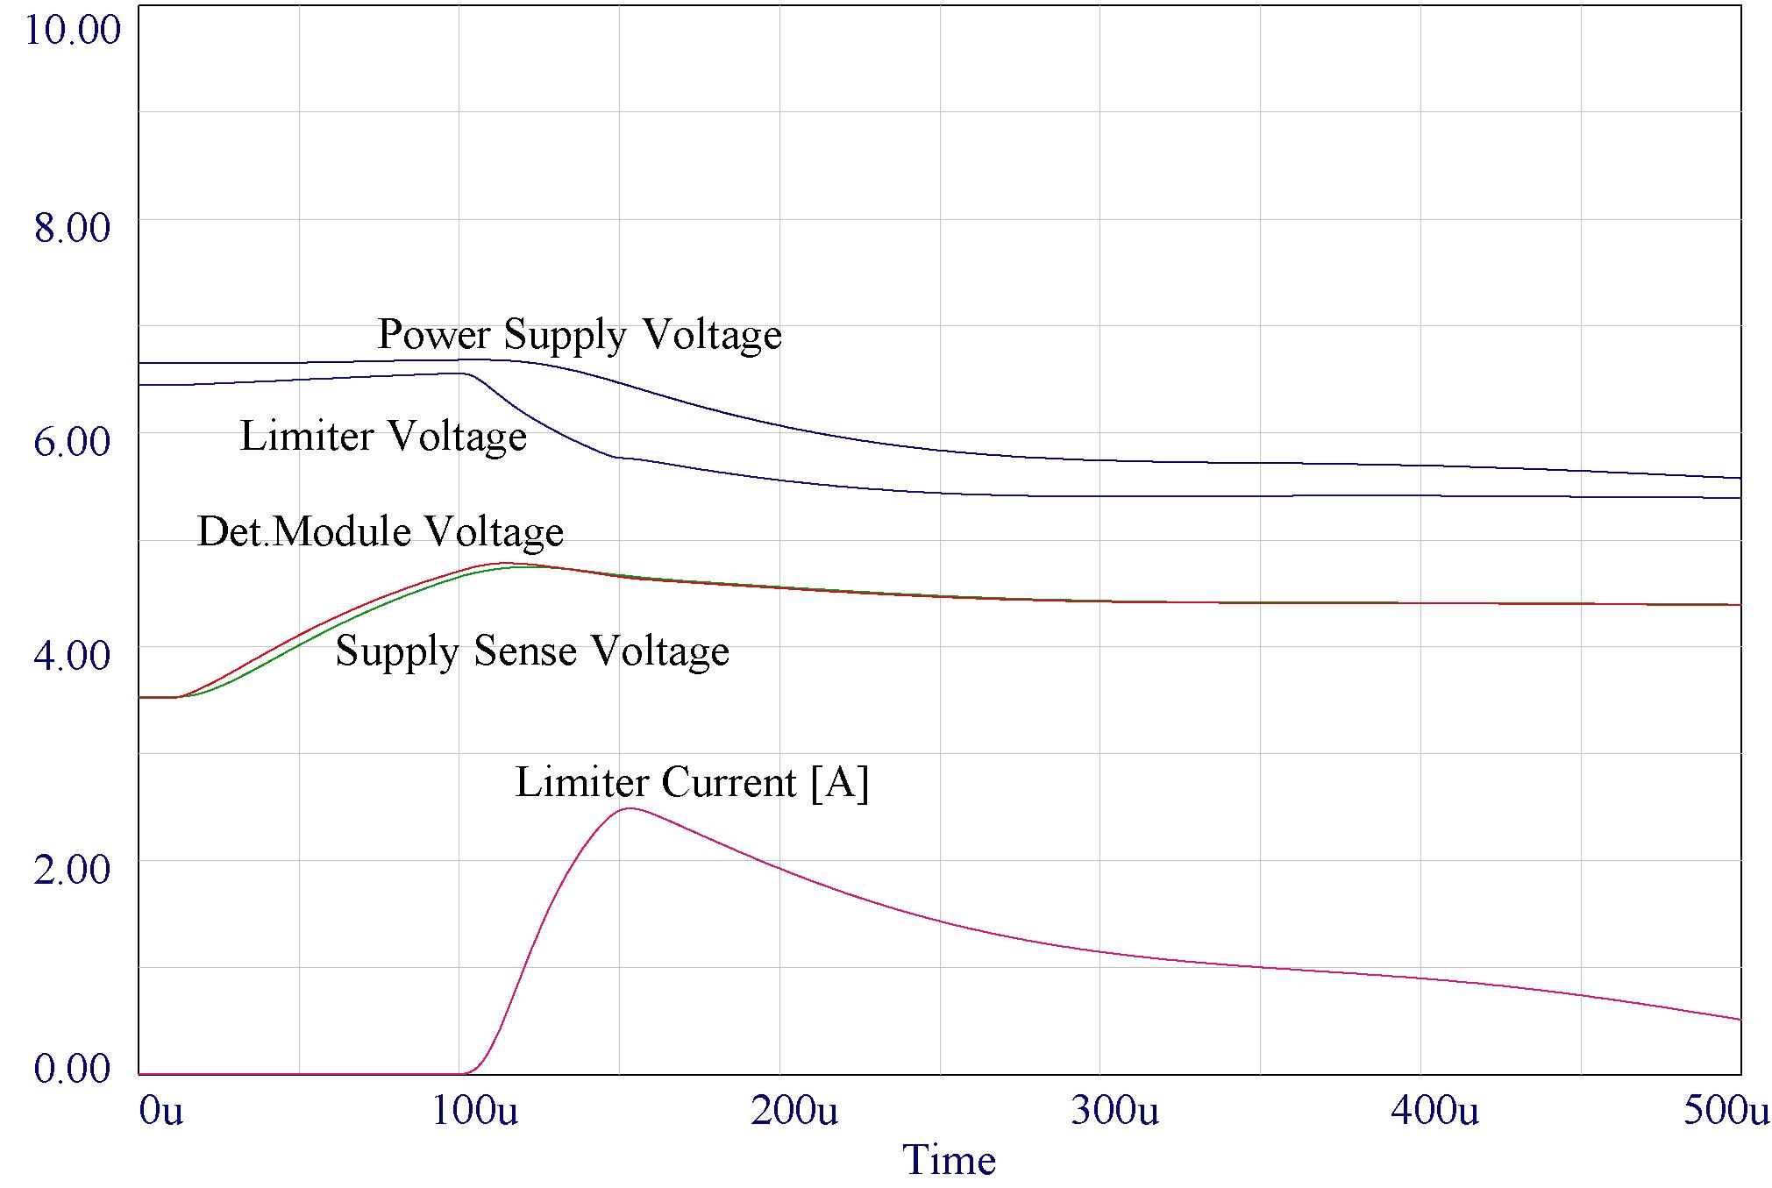

Fig 4 Simulation of voltages and currents when Icc is swithed form 820 mA to 230 mA with time constant as measured (see Fig 2). Line "Det. Module Voltage" means Vcc on the hybrid and should be compared with measurement.

3. Irradiation tests

3.1. Radiation environment

The voltage limiter position will be at patch panel 3 (PP3) which is inside the experimental area. Any electronic component used inside UX15 must be tested for radiation hardness. Worst case radiation levels at PP3 position (R = 1200 cm, Z = 0 to 1000 cm) accumulated in 10 years of operation will be (see appendix):
- total ionization dose 300 rad,
- NIEL fluence in 1 MeV equivalent neutrons Φ_{NIEL} = 6x10¹⁰ n/cm²
- fluence of fast hadrons (E > 20 MeV, relevant for SEE) Φ_{SEE} = 1.2x10¹⁰ p/cm²

To these levels one has to apply several safety factors according to the "ATLAS POLICY ON RADIATION TOLERANT ELECTRONICS". Taking these into account, levels to which the circuit must be tested are:

- total ionization dose 21000 rad,
- fluence of 1 MeV NIEL equivalent neutrons Φ_{NIEL} = 1.2x10¹² n/cm²
- fluence of fast hadrons (E > 20 MeV, relevant for SEE) Φ_{SEE} = 2.4x10¹¹ p/cm²

3.2 Components

The components used in the irradiated limiters (see also Fig 1):
- BD676 from SGS Thomson
- TL431 from SGS Thomson
- BC212B manufacturer unknown

3.3 Tests

Functionality of limiters was tested simulating conditions in ATLAS detector: power supply was connected to a load resistor over circuitry with capacitances and resistances similar to the situation in ATLAS experiment. With a switch the load resistance, simulating the SCT hybrid, was steeply increased. This caused a drop in current consumption which consequently would cause voltage increase on the load. The limiter must control this voltage increase and so protect the load against overvoltage.
In Fig 2 the simulation setup describing the measurement is shown. The load resistance is increased with the switch ST1 and voltage Vmod is monitored. Vmod must not exceed the limit set by the voltage limiter. This limiting voltage was measured on irradiated limiters.

3.4 Results

Irradiations of limiters were done at reactor facility in Ljubljana (neutrons and ionization) and at the The Svedeberg Laboratory in Uppsala, Sweden with 100 MeV protons.

Irradiation with ionizing radiation was done by inserting the sample into reactor core while the reactor was not operating (i.e. fission was stopped). Therefore the sample was exposed only to radiation (gamma) originating from the decay of fission products. Dosimetry was done with radfets. Radfets are MOS devices which measure the dose by measuring the threshold voltage shift caused by the charge trapped in the gate SiO₂.
Results of irradiation in reactor are summarized in Table 1. Irradiation with neutrons was done in two steps. In the first fluence was 2.5x10¹¹ n/cm² and in the second 3.5x10¹¹ n/cm² were added so that the total neutron fluence was 6x10¹¹ n/cm². The irradiated limiters were then irradiated also with ionization dose of 35 krad. During neutron irradiation the limiters were exposed to around 5 krad so that the total dose received by the limiters was 40 krad. Measurements were done at power supply voltage U = 6.8 V, current through the load resistor was 0.63 A, current through the limiter (when not limiting) was 0.29 mA. In Fig 3 plots of limiting voltage (average for the 12 devices) as a function of neutron fluence and ionization dose is shown.

 | Φ=0 | Φ=2.5e11 | Φ=6e11 | D=35 krad
Limiter No | Ulim0 | Ulim1 | Ulim2 | Ulim3
1 | 4.90 | 4.92 | 4.94 | 5.06
2 | 4.91 | 4.94 | 4.94 | 5.06
3 | 4.91 | 4.94 | 4.95 | 5.07
4 | 4.92 | 4.94 | 4.94 | 5.06
5 | 4.92 | 4.94 | 4.96 | 5.07
6 | 4.91 | 4.92 | 4.96 | 5.03
7 | 4.89 | 4.91 | 4.92 | 5.01
8 | 4.90 | 4.91 | 4.93 | 5.02
9 | 4.87 | 4.88 | 4.89 | 4.90
10 | 4.90 | 4.94 | 4.96 | 5.02
11 | 4.81 | 4.84 | 4.96 | 4.91
12 | 4.90 | 4.93 | 4.96 | 5.03
Average | 4.90 | 4.92 | 4.94 | 5.02

Table 1: Results of irradiation of limiters in the reactor in Ljubljana. Ionizing dose of 35 krad was added after neutron irradiation. Total ionizing dose received by the limiters was 40 krad.

Fig 5. Left: limiting voltage as a function of neutron fluence (in 1 MeV NIEL equivalent neutron). Right: limiting voltage as a function of ionizing dose.

Results of proton irradiation are summarized in Table 2. Load resistors were at 3.5 V, power supply voltage was 7.8 V, load current was 0.75 A. Resistors in the limiters were chosen so that the limiting voltage was 4.5 V.
Load voltage (Vmod) was monitored also on a scope to observe transients due to eventual SEE in the limiter. No spikes exceeding the noise level (~100 mV) were observed which could be related to the beam.
In figure Fig 4. limiting voltage is shown as a function of proton fluence

Limiter No | Ulim0 | Uim1 | Φ (p/cm2) | D(rad)
1 | 4.52 | 4.58 | 2.70E+11 | 26000
2 | 4.51 | 4.57 | 2.70E+11 | 26000
3 | 4.49 | 4.75 | 1.00E+12 | 100000
4 | 4.51 | 4.78 | 1.00E+12 | 100000

Table 2: Results of irradiation of limiters in 100 MeV proton beam in Uppsala.

Fig 6 Limiting voltage as a function of proton fluence.

4. Conclusions

Measurements of time dependence of limiter response proved that reaction time of the limiter at PP3 is sufficient. An overshoot of Vcc of 0.5 V after and of 50 μs duration is acceptable (see figures Fig 2 and Fig 3). Time response measurements are also in good agreement with simulation.

Irradiation tests also showed sufficient radiation hardness of the limiter design. Voltage limiters were irradiated with 100 MeV protons, reactor neutrons and gamma rays. Limiters were fully functional after any of irradiations. Increase in voltage limit as a consequence of irradiation was measured. Limiting voltage increased by 0.1 V after 6x10¹¹ n/cm² and 40 krad of ionization dose and by 0.3 V after 10¹² p/cm² (corresponding to 1.4x10¹² n/cm ² and 100 krad of ionization dose).
From reactor irradiation results shown in Fig 3. it can be concluded that Vlim increase during neutron irradiation was mostly caused by displacement damage (and not by ionization dose received together with neutrons). By this we can explain the kink in the Fig 3b plot. Therefore, assuming that the limiting voltage increases linearly with NIEL fluence and dose, we can make an approximation that:

${ΔV}_{\text{NIEL}}=\frac{0\text{.}\text{04}V}{6⋅{\text{10}}^{\text{11}}n/{{\text{cm}}^{2}}}=6\text{.}7⋅{\text{10}}^{−\text{14}}V/{{\text{ncm}}^{−2}}$ (1)

${ΔV}_{\text{IONIZ}}=\frac{0\text{.}\text{08}V}{\text{35}\text{krad}}=2\text{.}3⋅{\text{10}}^{−3}V/{\text{krad}}$ (2)

Using these numbers the proton irradiation results can be cross-checked. With protons NIEL fluence delivered was Φ_{NIEL} = 1.3·10¹² n/cm² and the ionization dose was D = 100 krad. If we assume that total voltage increase is a sum of increase caused by ionization dose and increase caused by NIEL than using numbers from (1) and (2) the prediction for limiting voltage increase for proton irradiation would be

$ΔV=6\text{.}7⋅{\text{10}}^{−\text{14}}V/{{\text{ncm}}^{−2}}⋅1\text{.}3⋅{\text{10}}^{\text{12}}n/{{\text{cm}}^{2}}+2\text{.}3⋅{\text{10}}^{−3}V/{\text{krad}}⋅\text{100}\text{krad}=0\text{.}\text{31}V$

which is in good agreement with 0.25 V measured.

The NIEL radiation level to which the limiters were tested with protons was higher then maximum required (with all the safety factors) for position R = 1200 cm and total dose also exceeded the required level by large extent. Irradiation with protons also proved that the limiters are not susceptible to destructive single event effects. Taking into account also good consistency between irradiations in Ljubljana and Uppsala we conclude that limiting voltage will increase by less than 0.13 V after 10 years in ATLAS. Therefore voltage limiters are sufficiently radiation hard to be used at PP3.

APPENDIX

Fig 1 Calculated total dose in ATLAS experiment at R = 1200 cm
Fig 2 Calculated NIEL in ATLAS experiment at R = 1200 cm

Fig 3. Calculated fluence of hadrons with energy E > 20 MeV in ATLAS experiment at R = 1200 cm.

