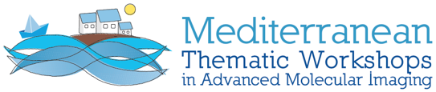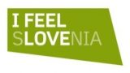

VII. MEDITERRANEAN THEMATIC WORKSHOP ON ADVANCED MOLECULAR IMAGING
MEDAMI 2022
http://medami2022.ijs.si/

Multimodality/Molecular Neuro-Imaging:
Clinical and Technical state-of-the-art and future developments

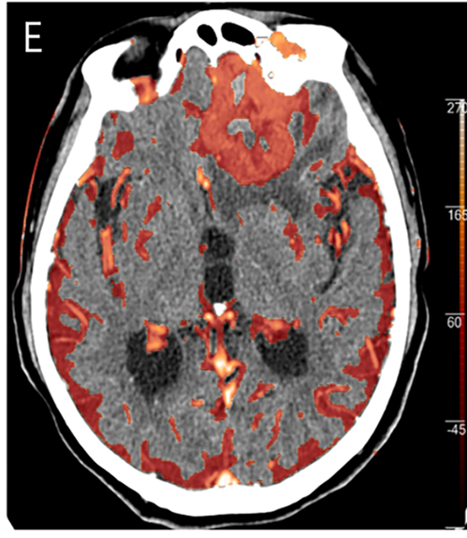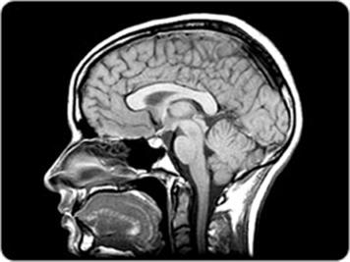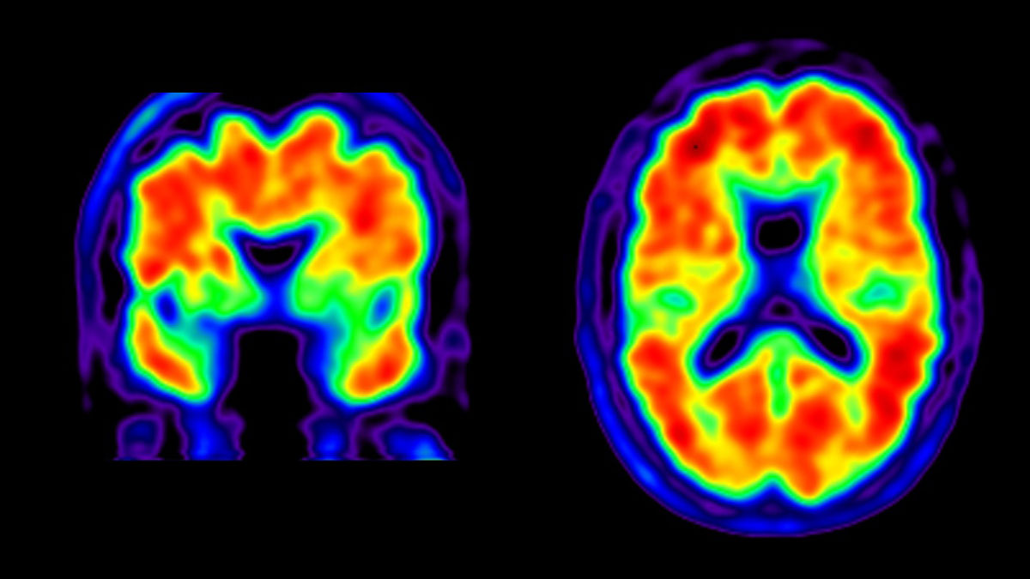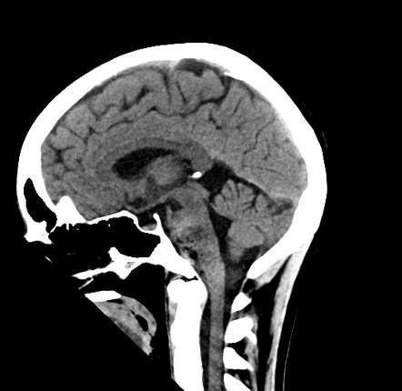

Grand Hotel Portorož, Slovenia, September 5-7, 2022

Dear Colleague,

Following the series of previously conducted symposia on dedicated medical imaging instrumentation, we are presently organizing the 7th issue of this event in the beautiful city of Portorož, Slovenia. Unfortunately due to the Covid-19 pandemics, the event has been postponed twice. We hope to meet you this year in-person.

The MEDAMI workshops are unique in that they are trying to address a medical imaging topic in its context and complexity between clinical application and technical development. Aside from providing an overview of the state-of-the-art, they are trying to both stimulate technological developments of imaging as well as its clinical use. Fundamental strategic questions of “where is it going?” are being discussed.

Some of the key topics this year’s forum shall address are:
- Brain Imaging in research and clinics- status and next frontiers
- Multimodality imaging advances in the context of understanding brain function in healthy subjects and in neurodegeneration/brain trauma
- Role of animal models in neurodegeneration/trauma/addiction/psychiatry
- Neurobiology of brain cancer
- Gut to brain connection: does it justify whole body scanners for brain imaging?
- Technical Advances in brain imaging:
  - TOF-PET: What timing resolution is needed? What is the impact?
  - Photon counting/spectral/low dose CT: revolutionizing trauma imaging?
  - Is there a role for brain only scanners?
  - AI/ML/Deep learning: what does it bring in imaging?
- How can we make imaging more accessible to a wider community?

Consistent with the spirit of this workshop, topics will be addressed from the medical, clinical and instrumentation perspective with the intent of fostering interactions between applications and technical developments.

The program of MEDAMI2022 is currently being developed and will be published on the conference website http://medami2022.ijs.si/ . Several Key Opinion Leaders in Biology, Medicine, and Technology have already been contacted to give lectures. We have a confirmation from Jose-Maria Bennloch, Irene Buvat, Rich Carson, Alberto Del Guerra, Roger Gunn, Thorsten Fleitner, Kristina Herfert, Roger Lecomte, Paul Lecoq, Craig Levin, Stan Majewski, Johan Nuyts, John Prior, Ilan Rabiner, Rok Pestotnik, Bernd Pichler, Vesna Sossi, and Kevin Whittingstall.

The meeting format fosters close interaction between different stakeholders from academia, medical institutions and organizations, regulatory agencies, and industry by providing enough time and chances for personal communication. We believe it is crucial to organize the event that will enable personal interaction with key stakeholders from academia & research, clinics, and regulatory. The program of the MEDAMI 2022 will primarily consist of invited talks by key opinion leaders and experts from around the world.

A limited number of abstracts for oral and poster presentations will also be accepted. If you have to report on a topic that you think fits into the scope of the program, we will be happy to consider your contribution.

We thank you in advance for considering your participation in this exclusive workshop, thus helping us to develop a unique interdisciplinary event into a productive meeting. Your presence at this multi-disciplinary meeting is crucial for its success.

Please join us in Portorož at the critical time of defining the future of medical imaging.

Important dates:
- Mar 10, 2022: 1st announcement of MEDAMI2022
- Mar 10, 2022: Call for abstracts: https://indico.cern.ch/event/851913/abstracts/
- Apr 27, 2022: 2nd announcement of MEDAMI2022
- May 20, 2022: 3nd announcement of MEDAMI2022
- May 31, 2022: Abstracts Submission Deadline
- Jun 15, 2022: Notification to Authors
- Jun 1, 2022: Early Bird Registration Opening
- Aug 10, 2022: Early Bird Registration closes
- After Sep 3, 2022, only on-site registration is possible
- Sept. 5-7: Conference

Conference Chairmen
Vesna Sossi / Peter Križan / John Prior
University of British Columbia, Vancouver/Ljubljana University, Slovenia/ Lausanne University, Switzerland

On behalf of the MEDAMI Organizing Committee:
J.M. Benlloch, A. Gonzalez, I3M, CSIC, Valencia, Spain
P. Lecoq, CERN, Geneva, Switzerland
F. Garibaldi, ISS&INFN, Rome, Italy
R. Lecomte, Universite de Sherbrooke, Canada
C. Levin, Stanford University, USA
S. Majewski, UC Davis, USA
R. Pestotnik, Jožef Stefan Institute, Slovenia
Y. Haemisch, Direct Conversion/Varex, Munich, Germany

Info email: medami2022.info@cern.ch

