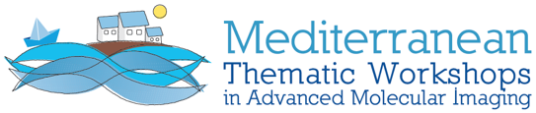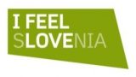

VII. MEDITERRANEAN THEMATIC WORKSHOP ON ADVANCED MOLECULAR IMAGING
MEDAMI 2022

Multimodality/Molecular Neuro-Imaging:
Clinical and Technical state-of-the-art and future developments

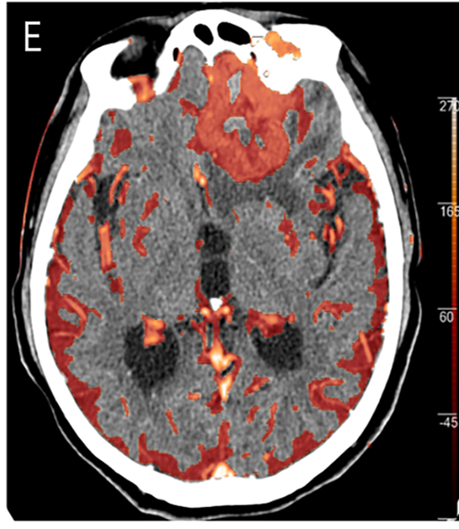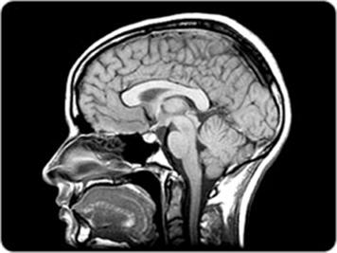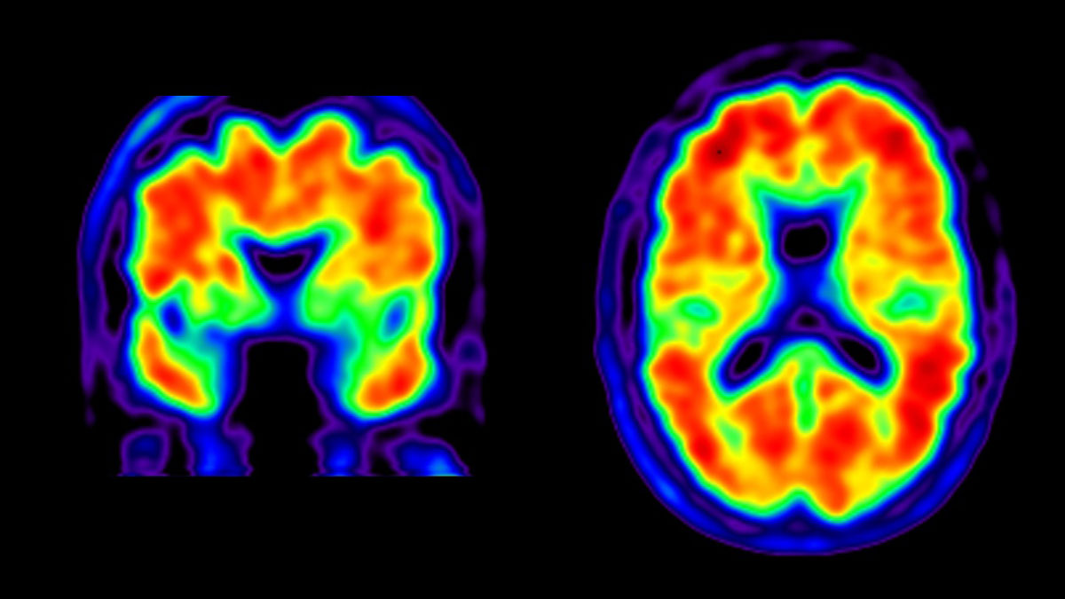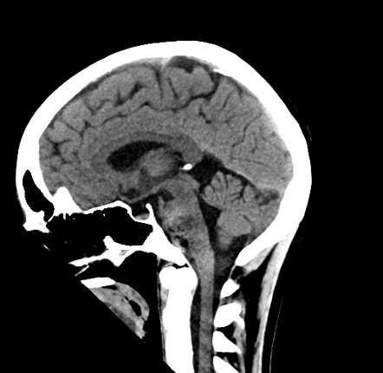

Grand Hotel Portorož, Slovenia, September 5-7, 2022

Dear Industrial Partner and Colleague,

Following the previously conducted symposia on dedicated medical imaging instrumentation and applications, we are presently organizing the 7th event of this series in the beautiful city of Portorož, Slovenia, for which we are asking your support. Covid-19 has caused unprecedented disruption in our daily lives and the epidemic has hampered in person networking events for longer than expected. Unfortunately, we had to postpone the event first planned for Sept. 2020 twice to Sept. 2022. We hope that this year we will be able to organize the event in-person.

The MEDAMI workshops are unique as they address a medical imaging topic in the context of the interaction and synergy between clinical applications and technical developments. In addition to providing an overview of the state-of-the-art, they aim to both stimulate technological developments and their clinical use. Fundamental strategic questions of “where is the field going?” are being discussed.

Some of the key topics this year’s forum shall address are:
- Brain Imaging - status and next frontiers
- Multimodality imaging in the context of understanding brain function in healthy subjects and in neurodegeneration/brain trauma/COVID-19
- Role of animal models in neurodegeneration/trauma/addiction/psychiatry
- Neurobiology of brain cancer
- Gut to brain connection: does it justify whole body scanners for brain imaging?
- Technical Advances in brain imaging:
TOF-PET: What timing resolution is needed? What is the impact?
Photon counting/spectral/low dose CT: revolutionizing trauma imaging?
Is there a role for brain only scanners?
AI/ML/Deep learning: what does it bring in imaging?
- How can we make imaging more accessible to a wider community?

Consistent with the spirit of this workshop, topics will be addressed from the medical, clinical and instrumentation perspectives.

The program of MEDAMI2022 is currently being developed and a link to the program will be provided. A number of Key Opinion Leaders in Biology, Medicine and Technology have already been contacted to give lectures. There will also be a second announcement with more information on the program.

The meeting format fosters close interaction between different stakeholders from academia, medical institutions and organizations, regulatory agencies, and industry by providing enough time and opportunities for personal interactions. We believe it is very important to have industry represented by visionaries and influencers in responsible positions that will use the chance of personal interaction with key stakeholders from academia & research, clinics and regulatory.
Industrial participant are specifically invited to play an important role by:

- Giving keynote lectures on the vision of industry towards neuroimaging.
- Actively participating in sessions and round table discussions.
- Conducting one-on-one meetings with key researchers in the field.

As all such events, aside from attendance fees, we are also relying on the support of the relevant industries. In order to allow participation of a full range of relevant companies and industries , we offer 3 sponsorship levels:

Level 1 (Gold):
5.0 k € and up includes: slot for keynote, active participation in round tables, logo on all materials, two free registrations)
Level 2 (Silver):
2.5 k € includes: active participation in round tables, logo on all materials, one free registration
Level 3 (Bronze):
1.0 k € includes: incl. logo on website and all materials
Registrations include lunches during conference and conference dinners.

We thank you in advance for considering your participation and support in turning this event into a productive and impactful meeting. We are considering your presence at this multi-disciplinary meeting to be crucial to its success.

We are very much looking forward to welcoming you in Portorož.

Conference Chairpersons
Vesna Sossi / Peter Križan / John Prior
University of British Columbia, Vancouver/Ljubljana University, Slovenia/ Lausanne University, Switzerland

On behalf of the MEDAMI Organizing Committee:
J.M. Benlloch, I3M, CSIC, Valencia, Spain
F. Garibaldi, ISS&INFN, Rome, Italy

A. Gonzalez, I3M, CSIC, Valencia, Spain
Y. Haemisch, Direct Conversion/Varex, Munich, Germany

R. Lecomte, Universite de Sherbrooke, Canada
P. Lecoq, CERN, Geneva, Switzerland

C. Levin, Stanford University, USA
S. Majewski, UC Davis, USA
R. Pestotnik, Jožef Stefan Institute, Slovenia

Info email: medami2022.info@cern.ch

MEDAMI2022 venue and information

For centuries, the town of Portorož (Slovenia) has been famous as a health and spa resort with its centuries-old healing tradition using natural healing factors as for example offered at the Terme Portorož. Portorož also provides premium culinary experiences based on Mediterranean Diet and is an excellent choice for travelers looking for active holidays, nightlife, relaxation or business meetings.

At walking distance from Portorož is Piran, one of the most picturesque towns on the Mediterranean coast. In Piran you will feel like walking through a beautifully painted landscape.

The conference will be held at Grand Hotel Portorož, a hotel with tradition and a full range of thermal spa facilities. The Grand Hotel Portorož has extensive meeting and exhibition facilities. James Cook Hall is an elegant and comfortable multipurpose room with space for over 160 people.

Getting to Portorož by road:  125 km from Ljubljana (SI),  33 km from Trieste (I),  190 km from Venice (I),  252 km from Zagreb (HR),  490 km from Vienna (A),  485 km from Munich (D). | Getting to Portorož by plane:  Ljubljana, Brnik (SI), 143 km, https://www.fraport-slovenija.si/en/Main  Trieste, Ronchi dei Legionari (I), 74 km https://triesteairport.it/en/  Venice (I) , 190 km, https://www.veniceairport.it/en/  Klagenfurt (A) 196 km, https://klagenfurt-airport.at/en/  Shuttle transfers can be conveniently booked from any of the airports.

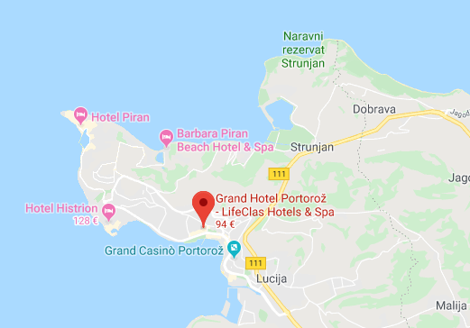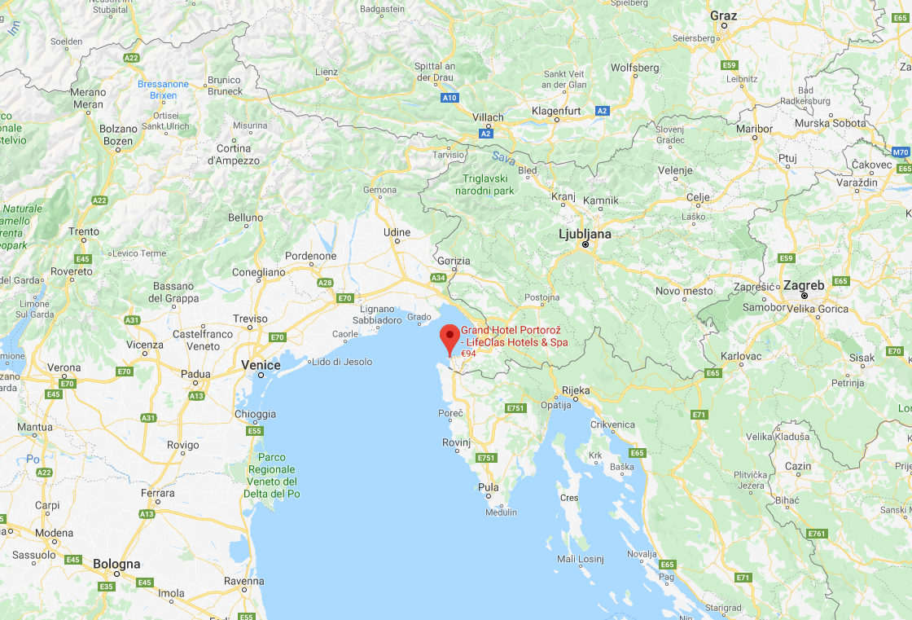

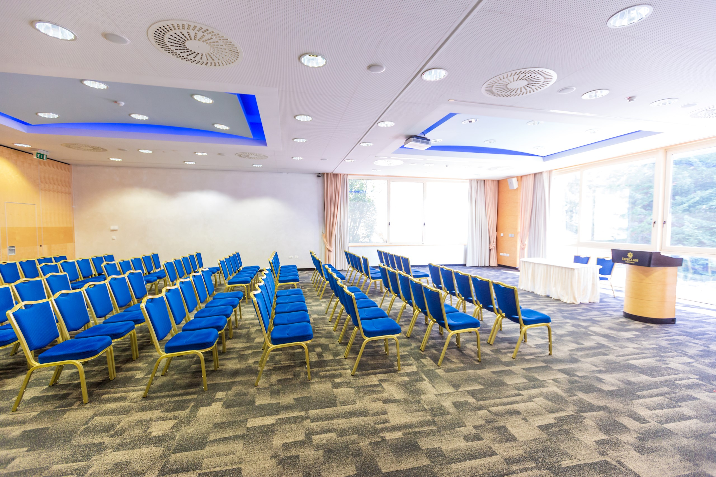

The hotel offers two different levels of accommodation at special MEDAMI2022 rates:
Double room single occupancy including breakfast: 120-140 €/night
Double room including breakfast: 150-170 €/night

